AUTOMATED IOT-BASED DRAINAGE MONITORING AND SOLID WASTE MANAGEMENT SYSTEM
A PROJECT REPORT
Submitted by
AASHIGAA C (8115U21CS003)
ABINAYADEVI C (8115U21CS006) ANU R (8115U21CS013)
HARINI N(8115U21CS044)

in partial fulfilment of the award of the degree of

BACHELOR OF ENGINEERING
in
COMPUTER SCIENCE AND ENGINEERING

K.RAMAKRISHNAN COLLEGE OF ENGINEERING
(AUTONOMOUS),


SAMAYAPURAM,TRICHY– 621112

MAY 2025

K. RAMAKRISHNAN COLLEGE OF ENGINEERING
(AUTONOMOUS)
BONAFIDE CERTIFICATE
Certified that this project report “AUTOMATED IOT-BASED DRAINAGE MONITORING AND SOLID WASTE MANAGEMENT SYSTEM ” is the
Bonafide work of “AASHIGAA C, ABINAYADEVI C, ANU R, HARINI N who carried out the project work under my supervision.

SIGNATURE SIGNATURE
Dr.T.M. NITHYA, M.E.,Ph.D Mrs.S.SARANYA,
Associate Professor Assistant Professor
HEAD OF THE DEPARTMENT SUPERVISOR
Computer Science & Engineering Computer Science & Engineering K.Ramakrishnan College of K.Ramakrishnan College of
Engineering ( Autonomous ) Engineering (Autonomous)
Samayapuram, Samayapuram,
Trichy–621112 Trichy–621112
Submitted for the Project Viva-Voce Examination held on ………………….

INTERNAL EXAMINER EXTERNAL
EXAMINER
ACKNOWLEDGEMENT
We thank the almighty GOD, without whom it would not have been possible
for us
to complete our project.
We wish to address our profound gratitude to Dr.K.RAMAKRISHNAN, Chairman,
K.Ramakrishnan College of Engineering (Autonomous), who encouraged and gave us all help throughout the course.
We express our hearty gratitude and thanks to our honourable and grateful Executive Director Dr.S.KUPPUSAMY,B.Sc.,MBA.,Ph.D., K.Ramakrishnan College of Engineering (Autonomous).
We are glad to thank our principal Dr.D.SRINIVASAN,M.E., Ph.D.,FIE.,MIIW.,MISTE.,MISAE.,C.Engg, for giving us permission to carryout this project.
We wish to convey our sincere thanks to Dr.T.M.NITHYA,M.E.,Ph.D., Head of the Department, Computer Science and Engineering forgiving us constants encouragement and advice throughout the course.
We are grateful to Mrs.S.SARANYA,M.E Assistant Professor in the Department of Computer Science and Engineering, K.Ramakrishnan College of Engineering (Autonomous), for his guidance and valuable suggestions during the course of study.
Finally, we sincerely acknowledged in no less term for all our staff members, our parents and friends for their co-operation and help at various stages of this project work.

DECLARATION

I here by declare that the work entitled “AUTOMATED IOT-BASED DRAINAGE MONITORING AND SOLID WASTE MANAGEMENT
SYSTEM ” is submitted in partial fulfilment of the requirement for the reward of
the degree in B.E., Anna University, Chennai, is a record of our own work carried out by me during the academic year 2022-2023 under the supervision and guidance of Mrs.S.SARANYA, Assistant professor, Department of Computer Science and Engineering, K.Ramakrishnan College of Engineering Autonomous). The extent and source of information are derived from the existing literature and have been indicated through the dissertation at the appropriate places. The matter embodied in this work is original and has not been submitted for the award of any degree or diploma, either in this or any other University.

AASHIGAA C (8115U21CS003)

I certify that the declaration made by above candidate is true.

Mrs.S.SARANYA
DECLARATION

I here by declare that the work entitled “AUTOMATED IOT-BASED DRAINAGE MONITORING AND SOLID WASTE MANAGEMENT
SYSTEM ” is submitted in partial fulfilment of the requirement for the reward of
the degree in B.E., Anna University, Chennai, is a record of our own work carried out by me during the academic year 2022-2023 under the supervision and guidance of Mrs.S.SARANYA, Assistant professor, Department of Computer Science and Engineering, K.Ramakrishnan College of Engineering Autonomous). The extent and source of information are derived from the existing literature and have been indicated through the dissertation at the appropriate places. The matter embodied in this work is original and has not been submitted for the award of any degree or diploma, either in this or any other University.

ABINAYADEVI C (8115U21CS006)

I certify that the declaration made by above candidate is true.
DECLARATION

I here by declare that the work entitled “AUTOMATED IOT-BASED DRAINAGE MONITORING AND SOLID WASTE MANAGEMENT
SYSTEM ” is submitted in partial fulfilment of the requirement for the reward of
the degree in B.E., Anna University, Chennai, is a record of our own work carried out by me during the academic year 2022-2023 under the supervision and guidance of Mrs.S.SARANYA, Assistant professor, Department of Computer Science and Engineering, K.Ramakrishnan College of Engineering Autonomous). The extent and source of information are derived from the existing literature and have been indicated through the dissertation at the appropriate places. The matter embodied in this work is original and has not been submitted for the award of any degree or diploma, either in this or any other University.

ANU R (8115U21CS013)

I certify that the declaration made by above candidate is true.

DECLARATION

I here by declare that the work entitled “AUTOMATED IOT-BASED DRAINAGE MONITORING AND SOLID WASTE MANAGEMENT
SYSTEM ” is submitted in partial fulfilment of the requirement for the reward of
the degree in B.E., Anna University, Chennai, is a record of our own work carried out by me during the academic year 2022-2023 under the supervision and guidance of Mrs.S.SARANYA, Assistant professor, Department of Computer Science and Engineering, K.Ramakrishnan College of Engineering Autonomous). The extent and source of information are derived from the existing literature and have been indicated through the dissertation at the appropriate places. The matter embodied in this work is original and has not been submitted for the award of any degree or diploma, either in this or any other University.

HARINI N (8115U21CS044)

I certify that the declaration made by above candidate is true.

TABLE CONTENT

S.NO | TITLE | PAGE NO
1  1.1  1.2  1.3  1.4  1.5 | INTRODUCTION  The Need for Smart Solutions in Drainage Management  IoT Technology and Its Role in Urban Infrastructure  Ultrasonic Sensors for Water Level Monitoring  Toxic Gas Detection for Worker and Public Safety  Real-Time Visualization via LCD and IoT Platforms | 14  16  16  17  17  17
2 | LITERATURE SURVEY | 27
3  3.1  3.2  3.3 | SYSTEM ANALYSIS  Existing system  Proposed System  Application | 37  37  40  44
4  4.1  4.2  4.3  4.4  4.5  4.6 | SYSTEM REQUIREMENT  Arduino ide  Libraries  Connecting the arduino  Preparing the board  Loading code  Proteus | 46  46  48  48  49  49  50

5  5.1  5.1.1  5.1.2  5.1.3  5.1.4  5.1.5  5.2  5.2.1  5.2.2  5.2.3  5.2.4  5.2.5  5.2.6 | SYSTEM DESIGN  Module explaination  Ultrasonic Sensor Module  The Toxic Gas Detection  IoT Communication Module  LCD Display Module  Buzzer Alert Module  Hardware implementation  Buzzer alert module  Nodemcu (esp8266)  Liquid crystal display  Buzzer  Ultrasonic sensor  Gas sensor | 53  53  53  54  54  55  55  56  56  61  67  69  70  73
6 | SYSTEM TESTING  6.1Results and Discussion  6.2 Arduino Iot cloud | 75  75
7  7.1  7.2 | CONCLUSION AND FUTURE ENHANCEMENT  Conclusion  Future enhancement | 79  79  80

8 | APPENDIXES | 81
9 | REFERANCE | 88

ABSTRACT
Rapid urbanization has significantly increased the burden on urban drainage systems, leading to frequent blockages, overflows, and hygiene-related challenges. These issues not only compromise public health and environmental safety but also strain municipal resources. To address these concerns, this project proposes an advanced Internet of Things (IoT)-based drainage monitoring and hazard detection system designed to enable real-time assessment, early warning, and efficient management of drainage infrastructure in urban environments.
The system utilizes ultrasonic sensors to continuously monitor wastewater levels and detect potential blockages, facilitating timely maintenance and reducing the risk of system failures. Toxic gas detection modules are integrated to identify the presence of harmful gases such as methane and hydrogen sulfide, safeguarding the health of sanitation workers and nearby residents. A key feature of the solution is its ability to deliver real-time status updates through LCD displays and IoT connectivity, ensuring seamless access to critical information for both field operators and centralized monitoring units.
Furthermore, the inclusion of automated buzzer alerts provides immediate warnings during critical events, enabling rapid response to mitigate potential hazards. This smart drainage monitoring solution not only enhances operational efficiency but also promotes public safety and hygiene by supporting proactive and preventive maintenance strategies. The proposed system serves as a scalable and cost-effective model for modern urban infrastructure, aligning with the growing need for sustainable and resilient smart city solutions.

 | LIST OF FIGURES
FIGURE NO. | FIGURENAME | PAGENO.
1.1 | Arduio Uno | 57
1.2 | ESP8266 | 61
1.3 | Power Supply | 66
1.4 | LCD Display Unit | 68
1.5 | Buzzer | 69
1.6 | Ultrasonic Sencer | 71
1.7 | Gas Sensor | 73

LIST OF ABBREVIATION

ABBREVIATION | EXPANSION
SASC | System application specific circuits
RTOS | Real Time Operating System
IOT | Internet of Things
NB-IoT | Narrowband IoT
IDE | Integrated Development Environment
VSM | Virtual System Modelling
MCU | Microcontroller Unit
LCD | Liquid Crystal Display

CHAPTER 1
INTRODUCTION
Urbanization, a hallmark of modern development, has brought with it numerous infrastructural challenges, particularly in the area of urban drainage systems. As cities continue to expand and population density increases, the pressure on existing drainage infrastructure has intensified. This often leads to problems such as waterlogging, sewage overflows, blockages, and overall degradation of hygiene and public health. Inefficient or outdated drainage systems fail to cope with the rapid influx of waste and stormwater, especially during monsoon seasons or heavy rainfall, resulting in serious disruptions in urban life. These issues are not only environmental and sanitary concerns but also pose significant health and safety risks to citizens and municipal workers involved in system maintenance.
Traditionally, urban drainage systems are monitored and maintained manually, which is time- consuming, labor-intensive, and often reactive rather than proactive. By the time an issue such as a blockage or gas buildup is detected, considerable damage may already have occurred. Moreover, maintenance workers are frequently exposed to hazardous environments, such as confined spaces filled with toxic gases, without adequate real-time information about the dangers present. These challenges highlight the urgent need for smarter, more responsive drainage system management approaches.
With the advancement of smart technologies, the integration of the Internet of Things (IoT) into urban infrastructure has emerged as a promising solution to modernize and enhance the efficiency of public utility services. IoT technology enables the collection, transmission, and analysis of real- time data from various sensors, providing critical insights that support faster decision-making and predictive maintenance strategies. By leveraging IoT, urban drainage systems can be transformed from passive conduits into active, self-monitoring networks that enhance city resilience, hygiene, and public safety.
The proposed IoT-based drainage monitoring and hazard detection system aims to address the limitations of traditional drainage management by incorporating a suite of smart sensors and real- time alert mechanisms. At the core of the system are ultrasonic sensors, which are employed
monitor the level of wastewater within the drainage pipes. These sensors provide continuous, non- contact measurements of fluid levels, making it possible to detect anomalies such as rising water levels or stagnation that may indicate a blockage or overflow. This early detection allows for timely intervention, reducing the risk of flooding or infrastructure damage.
Complementing this are toxic gas detection modules, which are essential for ensuring the safety of maintenance personnel. The presence of harmful gases such as methane (CH₄), hydrogen sulfide (H₂S), and ammonia (NH₃) in drainage systems poses severe health risks. These gases are often colorless and odorless, making them difficult to detect without specialized equipment. By integrating gas sensors into the IoT network, the system can monitor air quality within drainage zones in real time, immediately notifying authorities and field workers when gas concentrations exceed safe thresholds.
To make the system user-friendly and easily accessible, real-time data collected by the sensors is displayed on LCD screens and transmitted through IoT protocols to centralized monitoring platforms, such as mobile applications or web dashboards. This ensures that stakeholders— including municipal engineers, maintenance crews, and emergency response teams—can access up-to-date information on drainage system status at any time, from any location. The visual display component also allows for on-site monitoring, enabling quick assessments during inspections or emergency situations.
An additional safety feature integrated into the system is an automated buzzer alert mechanism, which activates when critical thresholds are reached. Whether it is a sudden spike in water level or a dangerous gas leak, the buzzer provides an audible alarm to signal immediate danger, prompting a swift response to prevent accidents, environmental contamination, or system failure. This real-time alert system is crucial for minimizing response time and averting potential disasters in urban drainage environments.
By adopting a smart, sensor-based architecture, this system offers several key advantages. It enhances efficiency by automating the detection of drainage issues; improves safety by reducing the exposure of workers to hazardous conditions; and promotes sustainability by enabling predictive maintenance and reducing environmental impact. Furthermore, the modular and scalable nature of the system allows it to be deployed in a wide range of urban settings—from small neighborhoods to large metropolitan areas—without significant infrastructure changes.

In conclusion, this IoT-driven drainage monitoring and hazard detection system represents a significant step forward in urban infrastructure management. By integrating ultrasonic sensors, toxic gas detectors, real-time display modules, and automated alert systems into a cohesive framework, the solution addresses both the operational and safety challenges posed by urban drainage systems. It exemplifies how smart technologies can be harnessed to build more resilient, hygienic, and sustainable cities, in line with the goals of modern urban planning and the Smart Cities Mission. The implementation of such systems is not merely a technological upgrade but a vital public service innovation that supports healthier, safer, and more livable urban environments.

The Need for Smart Solutions in Drainage Management

As cities aspire to become smarter and more sustainable, integrating digital technologies into public utilities has become essential. Smart drainage monitoring systems based on IoT (Internet of Things) present a significant opportunity to revolutionize how urban drainage networks are managed. By embedding smart sensors and communication modules within the drainage infrastructure, real-time data can be collected, analyzed, and acted upon.
Such systems support proactive decision-making, allowing authorities to predict potential issues and initiate timely responses. They also minimize human intervention in hazardous zones, improving safety and operational efficiency. Moreover, IoT-driven drainage monitoring contributes to environmental protection by reducing contamination risks and supporting better water management practices.

IoT Technology and Its Role in Urban Infrastructure

IoT is a network of physical devices embedded with sensors, software, and communication capabilities that collect and share data over the internet. In urban infrastructure, IoT can transform passive systems into intelligent, interconnected networks. For drainage monitoring, IoT facilitates automated and real-time assessment of fluid levels, gas concentrations, and environmental conditions.
Data collected by IoT-enabled sensors is transmitted wirelessly to central servers, cloud platforms, or mobile applications, where it can be visualized, logged, and used to trigger alerts or maintenance actions. This continuous feedback loop enhances transparency, responsiveness, and efficiency, which are vital components of smart city management

Ultrasonic Sensors for Water Level Monitoring

The proposed system incorporates ultrasonic sensors to monitor water levels in drainage pipelines and channels. These sensors use high-frequency sound waves to measure the distance between the sensor and the water surface. This non-contact method ensures durability and avoids sensor contamination.
By continuously measuring water levels, the system can detect blockages or rising levels that signal an impending overflow. Early detection allows municipal teams to dispatch cleaning units before the situation escalates, reducing damage and inconvenience to residents. It also helps optimize maintenance schedules and reduce emergency repair costs.

Toxic Gas Detection for Worker and Public Safety

Another crucial component of the system is the toxic gas detection module. Urban drainage systems often produce harmful gases like methane, ammonia, and hydrogen sulfide due to the decomposition of organic matter. These gases are invisible and sometimes odorless but can be fatal in high concentrations.
Gas sensors integrated into the IoT system constantly monitor gas levels. When thresholds are exceeded, alerts are generated to warn workers and authorities. This feature significantly enhances the safety of sanitation workers and prevents accidents during routine maintenance or inspections. It also allows authorities to assess risk levels before dispatching personnel, promoting safer working environments.

Real-Time Visualization via LCD and IoT Platforms

To make the system accessible and user-friendly, sensor data is displayed on LCD screens for local monitoring. Additionally, the information is transmitted via IoT modules (e.g., Wi-Fi, GSM, or LoRa) to cloud servers or mobile apps for remote access. This dual-display mechanism ensures that both on-site and centralized personnel can monitor system status in real time.
Cloud-based visualization platforms allow for historical data analysis, predictive maintenance planning, and performance optimization. Stakeholders, including municipal departments and emergency teams, can use this information to make data-driven decisions and improve resource allocation.

INTERNET OF THINGS

The Internet of Things (IoT) is a network of goods that include electronics, software, actuators, and connectivity, allowing these devices to connect, interact, and exchange data. The Internet of Things means extending Internet connectivity beyond standard devices such as PCs, laptops, smartphones, and tablets to a wide range of previously dumb or non-internet-enabled physical gadgets and everyday objects. These technologically implanted items can connect and interact over the Internet, and they can be remotely monitored and controlled.

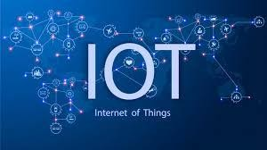
The definition of the Internet of Things has changed as a result of the convergence of several technologies, including real-time analytics, machine learning, inexpensive sensors, and embedded systems. The Internet of things is made possible by embedded systems, wireless sensor networks, control systems, automation (including home and building automation), and other conventional disciplines.

WORKING PROCESS

An Internet of Things (IoT) ecosystem is made up of web-enabled smart devices that employ embedded computers, sensors, and communication gear to gather, communicate, and act on environmental data. By connecting to an IoT gateway or other edge device, which either sends data to the cloud for analysis or analyzes it locally, IoT devices exchange the sensor data they gather. These gadgets converse with other similar devices on occasion, acting on the data they exchange. Although individuals may engage with the devices to set them up, give them instructions, or retrieve the data, the gadgets accomplish the majority of the job without their help. These web-enabled devices' connection, networking, and communication protocols are primarily determined by the particular IoT.

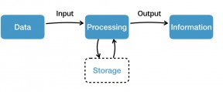

Fig1.2: Example of an IOT system

ADVANTAGES
Organizations can use the internet of things to:
- monitor their overall business processes;
- improve the customer experience;
- save time and money;
- increase employee productivity;
- integrate and adapt business models;
- make better business decisions; and
- generate more revenue.
IoT pushes organizations to reconsider how they approach their enterprises, sectors, and markets, and it provides them with the means to better their business plans.

ISSUES

The internet of things involves the usage of billions of data points and the connection of billions of devices to the internet, all of which must be protected. IoT security and privacy are important concerns due to its extended attack surface. Mirai, a botnet that hacked domain name server provider Dyn and brought down many websites for a long period of time in one of the largest distributed denial-of-service (DDoS) assaults ever witnessed, was one of the most prominent

recent IoT attacks. Attackers acquired network access by exploiting inadequately protected IoT devices.

Because IoT devices are so tightly linked, a hacker only has to exploit one weakness to corrupt all of the data, rendering it useless. Manufacturers that fail to update their gadgets on a regular basis, if at all, leave them open to hackers.

Furthermore, linked gadgets frequently prompt users to provide personal information such as names, ages, residences, phone numbers, and even social network accounts – information that hackers might exploit.

However, hackers aren't the only threat to the internet of things; IoT consumers are also concerned about their privacy. Companies that manufacture and distribute consumer IoT devices, for example, might utilize those devices to collect and sell personal data from customers. Aside from exposing personal data, IoT threatens key infrastructure such as power, transportation, and financial services.

APPLICATIONS

The applications of the Internet of Things (IoT) are vast and diverse, as the technology can be applied to various industries and use cases. Some common applications of IoT include:
Smart homes: IoT devices can be used to automate and control various home appliances and systems, such as lighting, heating, and security systems.
Industrial automation: IoT can be used to optimize and automate industrial processes, such as manufacturing, logistics, and supply chain management.
Healthcare: IoT devices can be used to monitor patient health and vital signs, automate medication management, and improve patient outcomes.
Agriculture: IoT can be used to monitor soil moisture, temperature, and other environmental factors to optimize crop yields and reduce water usage.
Smart cities: IoT can be used to optimize urban infrastructure, such as traffic management, waste management, and energy usage.

Transportation: IoT can be used to optimize transportation systems, such as monitoring traffic patterns and optimizing vehicle routes.
EMBEDDED SYSTEM
An embedded system is one kind of a computer system mainly designed to perform several tasks like to access, process, store and also control the data in various electronics-based systems. Embedded systems are a combination of hardware and software where software is usually known as firmware that is embedded into the hardware. One of its most important characteristics of these systems is, it gives the o/p within the time limits. Embedded systems support to make the work more perfect and convenient. So, we frequently use embedded systems in simple and complex devices too. The applications of embedded systems mainly involve in our real life for several devices like microwave, calculators, TV remote control, home security and neighborhood traffic control systems, etc.
An embedded system is integration of hardware and software, the software used in the embedded system is set of instructions which are termed as a program. The microprocessors or microcontrollers used in the hardware circuits of embedded systems are programmed to perform specific tasks by following the set of instructions. These programs are primarily written using any programming software like Proteus or Lab-view using any programming languages such as C or C++ or embedded C. Then, the program is dumped into the microprocessors or microcontrollers that are used in the embedded system circuits.

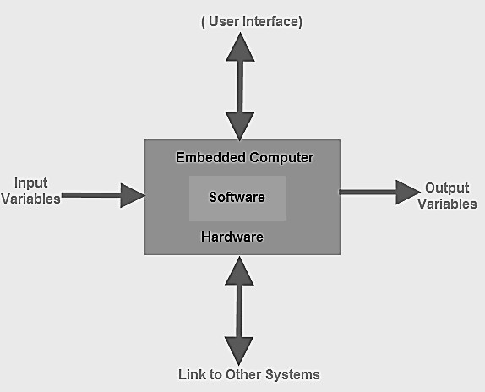

Embedded System Classification
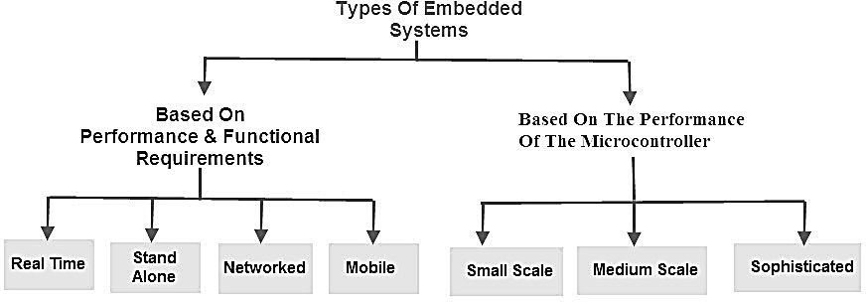

Embedded systems are primarily classified into different types based on complexity of hardware & software and microcontroller (8 or 16 or 32-bit). Thus, based on the performance of the microcontroller, embedded systems are classified into three types such as:
- Small scale embedded systems
- Medium scale embedded systems
- Sophisticated embedded systems

Further, based on performance and functional requirements of the system embedded system classified into four types such as:Real time embedded systems

- Standalone embedded systems
- Networked embedded systems
- Mobile embedded systems

Embedded System Hardware

An embedded system uses a hardware platform to perform the operation. Hardware of the embedded system is assembled with a microprocessor/microcontroller. It has the elements such as input/output interfaces, memory, user interface and the display unit. Generally, an embedded system comprises of the following
- Power Supply
- Memory
- Processor
- Timers
- Output/Output circuits
- Serial communication ports
- SASC (System application specific circuits)

Embedded System Software

The software of an embedded system is written to execute a particular function. It is normally written in a high-level setup and then compiled down to offer code that can be stuck within a non-volatile memory in the hardware. Embedded system software is intended to keep in view of the following three limits
- Convenience of system memory
- Convenience of processor’s speed
- When the embedded system runs constantly, there is a necessity to limit power dissipation for actions like run, stop and wake up.

RTOS (Real Time Operating System)

A system which is essential to finish its task and send its service on time, then only it said to be a real time operating system. RTOS controls the application software and affords a device to

allow the processor run. It is responsible for managing the different hardware resources of a personal computer and also host applications which run on the PC.
This operating system is specially designed to run various applications with an exact timing and a huge amount of consistency. Particularly, this can be significant in measurement & industrial automation systems where a delay of a program could cause a safety hazard.

Memory and Processors

The different kinds of processors used in an embedded system include Digital Signal Processor (DSP), microprocessor, RISC processor, microcontroller, ASSP processor, ASIP processor, and ARM processor. The different types of memories of an embedded system are given in the below chart.
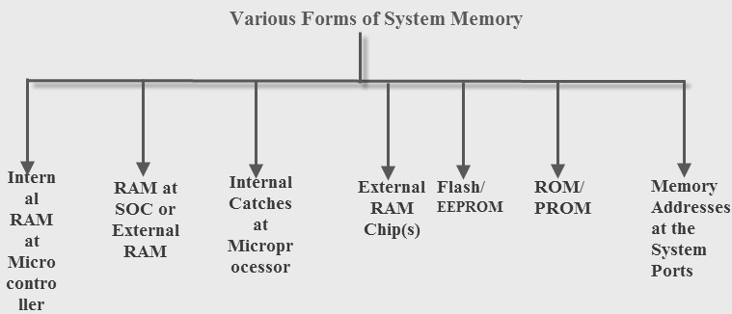

Embedded System Characteristics

- Generally, an embedded system executes a particular operation and does the similar continually. For instance: A pager is constantly functioning as a pager.
- All the computing systems have limitations on design metrics, but those can be especially tight. Design metric is a measure of an execution features like size, power, cost and also performance.
- It must perform fast enough and consume less power to increase battery life.
- Several embedded systems should constantly react to changes in the system and also calculate particular results in real time without any delay. For instance, a car cruise controller; it continuously displays and responds to speed & brake sensors. It must calculate acceleration/de-

accelerations frequently in a limited time; a delayed computation can consequence in letdown to control the car.
- It must be based on a microcontroller or microprocessor based.
- It must require a memory, as its software generally inserts in ROM. It does not require any secondary memories in the PC.
- It must need connected peripherals to attach input & output devices.
- An Embedded system is inbuilt with hardware and software where the hardware is used for security and performance and Software is used for more flexibility and features.

Embedded System Applications

The applications of an embedded system basics include smart cards, computer networking, satellites, telecommunications, digital consumer electronics, missiles, etc.
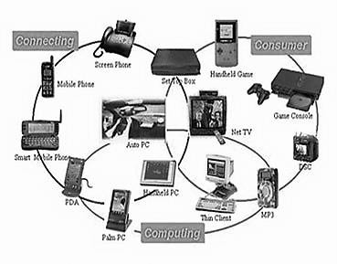

- Embedded systems in automobiles include motor control, cruise control, body safety, engine safety, robotics in an assembly line, car multimedia, car entertainment, E-com access, mobiles etc.
- Embedded systems in telecommunications include networking, mobile computing, and wireless communications, etc.
- Embedded systems in smart cards include banking, telephone and security systems.
- Embedded Systems in satellites and missiles include defense, communication, and aerospace.

OBJECTIVE :
  - To monitor wastewater levels using ultrasonic sensors for early detection of drainage blockages and overflow risks.
  - To detect toxic gases such as methane and hydrogen sulfide using gas sensors, ensuring safety for sanitation workers and nearby residents.
  - To enable real-time data collection and analysis through IoT integration for continuous drainage system monitoring.
  - To provide visual system status updates using LCD displays for on-site personnel and centralized control units.
  - To implement automated alert mechanisms via buzzers for immediate response to critical drainage issues.
  - To enhance urban hygiene and safety by enabling proactive and preventive drainage maintenance strategies.
  - To develop a scalable, cost-effective solution suitable for modern urban infrastructure and smart city applications.

CHAPTER 2

LITERATURE SURVEY
- TITLE : Developments and Applications of IoT-Based Sensors for Wastewater and Drainage Systems
AUTHOR : Robert Sitzenfrei, Ivar Annus, Jeroen Langeveld, Jörg Rieckermann, Wolfgang Rauch

YEAR : 2024

DESCRIPTION : The integration of Internet of Things (IoT) technology in wastewater and drainage systems has marked a significant evolution in urban infrastructure management. IoT- based sensors enable real-time monitoring, offering solutions to long-standing challenges such as blockages, overflow, and contamination in drainage systems. These sensors, such as ultrasonic, pressure, and flow sensors, are deployed at strategic points within the drainage network to collect data on wastewater levels, pipe conditions, and flow rates. The continuous data stream from these sensors is processed using cloud-based platforms, providing operators with insights for proactive maintenance and efficient resource management.
One of the key developments in IoT-based sensor applications is the integration of advanced communication technologies like Narrowband IoT (NB-IoT), which ensure reliable data transmission even in remote or densely built environments. This real-time data analysis not only helps detect and predict potential blockages and overflows but also allows for immediate response through automated alerts, reducing the risks associated with urban flooding. Furthermore, toxic gas detection sensors integrated into the systems provide an additional layer of safety, identifying harmful gases such as methane or hydrogen sulfide, thereby safeguarding public health and ensuring the safety of maintenance workers.
The versatility and scalability of IoT-based sensors have found applications in both urban and rural drainage systems, contributing to smarter, more resilient infrastructure. As cities continue to expand, these IoT solutions are becoming increasingly vital in achieving sustainable urban water management by improving the efficiency and responsiveness of wastewater and drainage systems, ultimately enhancing public health and reducing environmental hazards.
- TITLE : IoT-Oriented Approach for Rural and Urban Areas Based on ‘Smart Water Management Systems’ Through Sensors

AUTHOR : Chandra Prabha, Navneet Munoth

YEAR : 2023

DESCRIPTION : The rapid urbanization and increasing population in both rural and urban areas have amplified the challenges associated with water management, leading to inefficient resource utilization, water scarcity, and environmental concerns. To address these issues, the integration of Internet of Things (IoT) technology into water management systems has emerged as an innovative solution. By leveraging IoT-based sensors, water systems can be monitored in real-time, ensuring better management of water resources. In both rural and urban settings, IoT-enabled smart water management systems offer a decentralized approach to tracking water levels, flow rates, and quality, allowing for more efficient and responsive decision-making.
In urban areas, these systems can help prevent issues such as overflows, leaks, and water pollution by providing continuous data on water consumption and distribution. The IoT sensors can detect irregularities in water flow or quality, triggering automated responses such as activating water pumps or notifying authorities for maintenance needs. In rural areas, IoT-based smart water management systems ensure equitable access to water by monitoring supply in remote areas, detecting contamination, and providing insights into optimal water usage for agriculture and daily needs. The real-time data collected from these sensors can be transmitted to centralized platforms for analysis, enabling proactive interventions and reducing wastage.
This approach enhances both water quality and distribution efficiency, promotes sustainability, and improves water conservation practices. As a result, IoT-oriented smart water management systems present a promising solution for balancing water usage in diverse environments while minimizing resource wastage and ensuring long-term sustainability.

- TITLE : IoT-Based Flood Detection and Management Systems in Urban Areas

AUTHOR : Srinjoy Sengupta

YEAR : 2023

DESCRIPTION : Flooding is a significant urban challenge, exacerbated by rapid urbanization, climate change, and inadequate drainage infrastructure. IoT-based flood detection and management systems have emerged as effective solutions to mitigate flood risks and enhance urban resilience. These systems utilize a network of interconnected sensors, such as water level sensors, rainfall detectors, and temperature sensors, which continuously monitor various environmental parameters in real time. The data collected by these sensors is transmitted to centralized platforms via IoT technologies, enabling timely analysis and decision-making.
One of the key benefits of IoT-based systems is their ability to provide early warning alerts, allowing for proactive measures to be taken before floodwaters become a significant threat. For instance, when water levels exceed a predefined threshold, the system can trigger an automated alert to local authorities, residents, and emergency response teams, enabling quick action. Additionally, IoT sensors can be integrated with weather forecasting systems, offering more accurate predictions and tailored flood management strategies.
Furthermore, IoT systems enable better management of drainage systems by identifying blockages and inefficiencies in real time, preventing potential overflows. The integration of machine learning algorithms further enhances predictive capabilities, optimizing the system’s responsiveness and resource allocation. In urban areas, where flooding can cause widespread damage to infrastructure, homes, and public safety, IoT-based flood detection and management systems offer a cost- effective, scalable, and real-time solution to improve disaster preparedness and response efforts, ultimately enhancing the quality of life in cities.

- TITLE : Urban Underground Drainage Monitoring System Using IoT

AUTHOR : D. Deepak Kumar, N. Indrajith, R. Bhavya, Dr. V. Jayaprakasan

YEAR : 2021

DESCRIPTION : The Urban Underground Drainage Monitoring System Using IoT focuses on leveraging the power of Internet of Things (IoT) technologies to enhance the monitoring and management of urban underground drainage systems. These drainage systems are crucial for preventing flooding, waterlogging, and maintaining hygiene within urban areas, but they often suffer from inefficiencies and failures due to blockages, overflow, or deterioration. Traditional methods of monitoring these systems are often manual and can be reactive, leading to delayed maintenance and system failures.
By integrating IoT-based sensors into the drainage infrastructure, real-time data collection becomes possible, providing continuous monitoring of wastewater levels, blockages, and overall system performance. Ultrasonic sensors are typically used to measure water levels and detect potential blockages, while gas sensors can identify hazardous gases such as methane or hydrogen sulfide, ensuring the safety of both workers and residents. These sensors send data to a central system via wireless communication protocols like Wi-Fi or LoRaWAN, enabling immediate alerts and real-time updates.
The system also incorporates automated alert mechanisms such as buzzers or notifications through a mobile or web-based interface, enabling quick responses to prevent further damage or system failure. Additionally, data from the system can be displayed on LCD screens for on-site staff, and cloud-based platforms can be used for long-term monitoring and analysis, allowing for predictive maintenance and efficient resource allocation. This IoT-driven approach ensures proactive, efficient, and sustainable management of urban underground drainage systems, significantly reducing operational costs and improving overall public health and safety.

- TITLE : IoT-Based Detection of Blockages in Stormwater Drains

AUTHOR : Marlon Navia, Jessica Macías-Aguayo, Dennis Quiroz-Cordova

YEAR :2024

DESCRIPTION : The increasing frequency of urban flooding and drainage blockages has raised significant concerns regarding the efficiency of stormwater management systems. Traditional methods of detecting and addressing blockages in stormwater drains often rely on manual inspections or infrequent monitoring, which can lead to delayed responses and costly damage. To tackle these challenges, an Internet of Things (IoT)-based approach offers an innovative solution for real-time detection and management of blockages in stormwater drains. By integrating IoT sensors such as ultrasonic sensors, flow meters, and pressure sensors, stormwater systems can continuously monitor water levels, flow rates, and the presence of debris or blockages within the drainage network.
Ultrasonic sensors are particularly useful in measuring the water level within drains, detecting unusual rises that could signal a blockage. In combination with flow meters, they provide a comprehensive overview of the drainage conditions, identifying slow-moving or stagnant water, which is a typical indicator of blockages. IoT-enabled systems can send real-time data to cloud platforms or local monitoring units, allowing for immediate intervention and maintenance scheduling. This proactive approach significantly reduces the risk of system failures, minimizing flooding and infrastructure damage.
Furthermore, the integration of smart alerts, such as SMS or app notifications, ensures that maintenance teams are promptly alerted when critical blockages are detected, enabling faster responses. By automating the detection process, IoT-based blockage detection systems not only optimize resource use but also contribute to more sustainable urban drainage management, providing a cost-effective, scalable solution to an ever-growing problem in urban areas.

- TITLE : Monitoring and Control of Smart Urban Drainage Systems Using NB-IoT Cellular Sensor Networks

AUTHOR : Priit Roosipuu, Ivar Annus, Alar Kuusik, Nils Kändler, Muhammad Mahtab Alam

YEAR : 2023

DESCRIPTION : Urban drainage systems face numerous challenges, including blockages, overflows, and inefficient water management, particularly in rapidly growing cities. Traditional methods of monitoring these systems are often reactive and labor-intensive, leading to delayed responses to critical issues. To address these challenges, the integration of Internet of Things (IoT) technologies has proven to be a transformative solution. One such advancement is the use of Narrowband IoT (NB-IoT) cellular sensor networks, which provide a reliable and scalable communication framework for monitoring and controlling smart urban drainage systems. NB-IoT is an ideal communication technology for urban infrastructure, as it offers wide-area coverage, low power consumption, and the ability to handle a large number of sensors with minimal cost. By deploying NB-IoT-enabled sensors throughout drainage systems, municipalities can continuously monitor key parameters, such as water levels, flow rates, and the presence of blockages or hazardous gases. This real-time data is transmitted to a central system, where it can be analyzed to identify potential issues, predict system failures, and trigger automatic responses. The integration of NB-IoT sensors with advanced control algorithms enables proactive maintenance, reduces the risk of flooding, and improves overall system efficiency. Furthermore, the low power consumption of NB-IoT ensures that sensors can operate for extended periods without the need for frequent battery replacements, making the system highly cost-effective and sustainable. Overall, the use of NB-IoT cellular sensor networks enhances the performance, reliability, and sustainability of urban drainage systems, contributing to smarter, safer cities.

- TITLE : IoT-Based Smart Sewage Monitoring System for Smart City

AUTHOR : Priya Tiwari

YEAR : 2021

DESCRIPTION : The rapid growth of urbanization has significantly increased the strain on sewage and drainage systems, leading to challenges in maintaining cleanliness, preventing blockages, and managing wastewater efficiently. The introduction of Internet of Things (IoT)- based smart sewage monitoring systems can revolutionize the way cities address these challenges. In a smart city, IoT can facilitate real-time monitoring of sewage networks by integrating various sensors, such as ultrasonic, flow, and gas sensors, into the existing infrastructure. These sensors provide continuous data on wastewater levels, flow rates, and the presence of harmful gases like methane or hydrogen sulfide.
The integration of IoT enables centralized data collection and analysis, allowing city authorities to identify potential issues like blockages, overflows, or contamination before they become critical. By leveraging cloud computing and advanced data analytics, predictive models can be developed to forecast maintenance needs and optimize the flow of wastewater. Furthermore, the system can be equipped with automatic alert mechanisms, such as SMS or email notifications, to inform authorities and maintenance teams of potential issues in real time, ensuring prompt responses and minimizing system downtime.
Additionally, the use of IoT in sewage monitoring promotes the concept of a sustainable and resilient smart city. It not only improves the overall efficiency of wastewater management but also enhances public health and safety by minimizing exposure to hazardous substances. The ability to make data-driven decisions further supports the city's goals of sustainability and resource optimization, making the IoT-based smart sewage monitoring system a vital component of smart city infrastructure.

- TITLE : An IoT-Based Water-Logging Detection System: A Case Study of Dhaka

AUTHOR : Md Manirul Islam, Md. Sadad Mahamud, Umme Salsabil, A. A. M. Mazharul Amin, Samiul Haque Suman
YEAR : 2024

DESCRIPTION : Dhaka, the capital of Bangladesh, faces significant urban drainage challenges, particularly due to water-logging during the monsoon season. This issue not only disrupts daily life but also poses a serious threat to public health and infrastructure. In response, an IoT-based water-logging detection system has been proposed to monitor and manage water levels across the city in real-time. The system utilizes a network of sensors, including ultrasonic sensors for measuring water levels and gas sensors to detect potential hazards such as methane and hydrogen sulfide in flooded areas. These sensors are strategically placed in drainage systems, underpasses, and key flood-prone zones to provide continuous data transmission via wireless communication technologies. The data collected is processed and analyzed through a cloud-based platform, providing city officials with immediate, actionable insights for efficient water-logging management. Additionally, the system integrates automated alert mechanisms, such as SMS notifications or app-based alerts, to warn residents and emergency responders about rising water levels and possible blockages. This proactive approach allows for quicker intervention, minimizing the adverse effects of water-logging. The case study of Dhaka highlights the effectiveness of IoT in urban flood management, emphasizing how real-time monitoring can improve infrastructure resilience and enhance public safety. By implementing such smart systems, Dhaka can better manage its drainage challenges, ensuring a cleaner and more sustainable urban environment.

- TITLE : Sensors on the Internet of Things Systems for Urban Disaster Management: A Systematic Literature Review

AUTHOR : G. Furquim, F. Neto, G. Pessin, J. Ueyama, J.P. de Albuquerque, M. Clara, E.M. Mendiondo, V.C.B. de Souza, P. de Souza, D. Dimitrova, et al.
YEAR : 2023

DESCRIPTION : The paper titled "Sensors on the Internet of Things Systems for Urban Disaster Management: A Systematic Literature Review" provides a comprehensive review of how Internet of Things (IoT) sensors are revolutionizing urban disaster management systems. With rapid urbanization and increasing environmental risks, cities face heightened vulnerabilities to various disasters, such as floods, earthquakes, and fires. IoT systems, particularly those incorporating a wide array of sensors, are emerging as crucial tools for enhancing urban resilience and disaster preparedness. The paper systematically reviews recent research, highlighting the integration of IoT sensors, including temperature, humidity, motion, gas, and water level sensors, in disaster detection and management. These sensors facilitate real-time monitoring and data collection, enabling early detection of hazardous conditions such as floods, air quality deterioration, or gas leaks, thereby supporting timely intervention. By harnessing IoT-based networks, cities can proactively mitigate the impacts of disasters, improve response times, and optimize resource allocation. The review also emphasizes the role of data analytics and machine learning algorithms in processing the massive amounts of data generated by IoT sensors, turning raw data into actionable insights. Moreover, the paper explores challenges such as network reliability, sensor accuracy, and data privacy issues that must be addressed to ensure the effectiveness of IoT systems in disaster management. In conclusion, IoT sensors offer immense potential to transform urban disaster management by providing real-time, actionable information, thus ensuring enhanced safety and minimizing the damage caused by urban disasters. This review serves as a valuable resource for researchers and practitioners aiming to leverage IoT for building resilient and disaster-ready cities.

- TITLE : IoT-Based Water Monitoring Systems: A Systematic Review

AUTHOR : Che Zalina Zulkifli, Salem Garfan, Mohammed Talal, A. H. Alamoodi, Amneh Alamleh, Ibraheem Y. Y. Ahmaro, Suliana Sulaiman, Abu Bakar Ibrahim, B. B. Zaidan, Amelia Ritahani Ismail
YEAR : 2022

DESCRIPTION : The increasing global demand for water and the growing challenges in managing water resources have led to the widespread adoption of Internet of Things (IoT)-based water monitoring systems. These systems offer innovative solutions to monitor and manage water quality, supply, and distribution in real-time, providing significant improvements over traditional methods. This systematic review explores the various IoT-based water monitoring systems that have been developed and implemented in recent years. It examines the role of IoT technologies in enhancing the monitoring of water parameters such as pH, turbidity, temperature, and dissolved oxygen, which are crucial for assessing water quality.
IoT-based systems integrate various sensors, wireless communication technologies, and cloud computing to collect, transmit, and analyze data in real-time. These systems offer several advantages, including early detection of water quality issues, remote monitoring, and the ability to provide timely alerts for water treatment facilities or municipal authorities. Furthermore, IoT-based water monitoring systems facilitate continuous data collection, enabling better decision-making and more efficient management of water resources.
This review also highlights the challenges faced by these systems, such as sensor calibration, data security, and energy consumption, and discusses potential solutions. Moreover, the integration of machine learning and artificial intelligence into IoT systems is explored as a way to enhance predictive capabilities and automation. Overall, IoT-based water monitoring systems have the potential to transform the management of water resources, making it more efficient, cost-effective, and sustainable, which is crucial in addressing global water scarcity issues.

CHAPTER 3

SYSTEM ANALYSIS
EXISTING SYSTEM
As urbanization accelerates globally, cities are facing growing challenges in managing their drainage systems. The increasing population density, coupled with urban development, has placed immense pressure on existing drainage infrastructure. This pressure often leads to blockages, overflows, and a host of other operational failures that impact public health, the environment, and overall urban livability. Traditional drainage systems, which primarily rely on periodic manual inspections and reactive maintenance, are ill-equipped to address the real-time complexities of urban drainage management. As a result, cities experience frequent disruptions, including flooding, unsanitary conditions, and the spread of diseases linked to poor waste management. In response to these challenges, various technologies have been proposed to enhance the monitoring, management, and maintenance of drainage systems, with particular emphasis on IoT-based solutions that offer real-time data collection and analysis.
Conventional drainage systems typically rely on fixed infrastructure such as pipes, gutters, and sewer lines that transport wastewater and stormwater away from populated areas. However, these systems often lack the capability to monitor conditions in real time, which means any faults, such as blockages or capacity overloads, go unnoticed until significant damage or hazards occur. In most cases, the maintenance of such systems is reactive rather than proactive, with workers inspecting the pipes or sewers manually or responding to complaints from residents. Moreover, without an effective mechanism for detecting hazardous gases or wastewater overflow, these systems pose serious health risks to both residents and maintenance personnel. In addition to this, the inability to assess the real-time state of drainage systems increases the risk of delayed interventions, often leading to major public health and environmental disasters.
To combat these limitations, several existing IoT-based drainage monitoring systems have emerged in recent years, leveraging sensors, cloud computing, and advanced communication technologies to enable proactive and efficient management. IoT (Internet of Things) systems integrate sensors such as ultrasonic, temperature, humidity, and toxic gas detectors with centralized data analytics platforms to monitor the conditions of drainage systems continuously. These systems provide real- time alerts, allowing for early detection of potential issues such as clogs, overflow, and gas leaks,

which might otherwise go unnoticed. For example, ultrasonic sensors are increasingly used to monitor the level of wastewater in drainage pipes and tanks. These sensors emit high-frequency sound waves that bounce off the surface of the wastewater, and the time it takes for the sound waves to return is used to determine the water level. When the water level reaches a critical threshold, indicating the risk of overflow or blockage, the system can send an alert to maintenance crews or municipal authorities for prompt action. This continuous level monitoring helps avoid flood risks and system breakdowns that result from system overcapacity.
Similarly, other IoT-enabled systems focus on the detection of toxic gases such as methane, hydrogen sulfide, and ammonia that are often present in wastewater and sewer environments. These gases can pose serious health risks to maintenance personnel and residents, particularly when sewer lines are damaged or improperly vented. In response to this, several smart gas detection modules have been incorporated into IoT-based drainage systems. These sensors can continuously detect and measure the concentration of hazardous gases in the environment, triggering an automatic warning system when dangerous levels are detected. Such measures are particularly important for ensuring the safety of workers who maintain drainage systems and for preventing health hazards in areas surrounding sewage systems. By detecting harmful gases in real time, IoT systems ensure that timely responses are initiated to protect public health and the safety of workers.
Existing systems also incorporate mobile applications and cloud-based platforms to provide seamless communication between field operations and central monitoring stations. These systems can deliver up-to-date information about drainage conditions and provide immediate alerts in the event of an emergency, such as a blockage, overflow, or toxic gas detection. Cloud platforms enable remote access to system data, allowing municipal operators or engineers to monitor the performance of the drainage network from anywhere, at any time. The integration of mobile technology further enhances the real-time capabilities of these systems by ensuring that operators receive instant notifications about the status of drainage systems, which significantly improves response times during emergencies.
In addition to this, some advanced IoT systems integrate automated mechanisms to provide direct interventions when issues are detected. For instance, when a blockage is detected in a specific section of the drainage system, an automated actuator such as a valve or servo motor can be

triggered to manage the flow or release pressure, reducing the risk of damage or overflow. Additionally, automated alerts through loudspeakers or buzzers notify personnel and residents of critical situations, prompting rapid corrective actions. This automated approach helps avoid human error and delays in addressing drainage issues, which is particularly important for large-scale urban environments where manual monitoring of every section of the system would be impractical.
While these systems are still being refined, they are already showing great potential in addressing the major shortcomings of traditional drainage management. For instance, cities such as Barcelona and Singapore have pioneered the implementation of IoT-based systems to monitor urban drainage, integrating real-time data into decision-making processes to better manage stormwater runoff and prevent flooding. Similarly, New York City has deployed IoT-enabled sensors across its wastewater system to track flow rates, water quality, and potential blockages, allowing for more proactive maintenance of its aging infrastructure. These examples underscore the significant promise that IoT systems hold for transforming the way drainage systems are managed, enhancing the reliability, efficiency, and safety of urban wastewater management networks.
In conclusion, the adoption of IoT-based drainage monitoring and management systems represents a significant advancement in the way urban drainage systems are monitored and maintained. These technologies provide real-time monitoring, enabling cities to identify and address problems before they escalate into major issues. By integrating sensors for wastewater level measurement, toxic gas detection, and automated alerts, these systems ensure not only the efficient operation of urban drainage networks but also the safety and well-being of residents and maintenance workers. As IoT technology continues to evolve, the potential for smart drainage solutions will expand, ultimately contributing to more sustainable, resilient, and safer urban environments.

DISADVANTAGE
- High Initial Setup Costs: Implementing IoT-based drainage systems requires significant investment in sensors, infrastructure, and cloud platforms, making it expensive for municipalities, especially in developing regions, to adopt these solutions.

- Maintenance and Calibration of Sensors: IoT sensors, particularly ultrasonic and gas detection modules, require regular maintenance and calibration to ensure accurate readings. This ongoing maintenance can incur additional costs and may be challenging in hard-to- reach locations.
- Data Overload and Management: IoT systems generate large volumes of real-time data, which can overwhelm monitoring platforms if not properly managed. Processing and analyzing this data in a timely manner requires advanced data analytics, which may not be feasible for all municipalities.
- Power Supply Dependence: Many IoT sensors rely on batteries or external power sources, which may fail or need frequent replacement. In remote or hard-to-access drainage areas, this can lead to sensor malfunctions or gaps in monitoring data.
- Network Connectivity Issues: Effective IoT systems require reliable network connectivity to transmit real-time data to central platforms. In areas with poor network infrastructure, especially in rural or underserved urban environments, connectivity issues may limit the system's effectiveness.
- Security and Privacy Concerns: As IoT systems involve the collection and transmission of sensitive data, there are potential cybersecurity risks. Unauthorized access to the system could lead to tampering with sensor data or disruption of critical operations, potentially compromising public safety.
PROPOSED SYSTEM
Urban drainage systems are vital infrastructure elements that help manage wastewater and stormwater in cities. However, with the rapid pace of urbanization, the load on these systems has increased significantly. This often leads to overburdened drainage networks, causing issues such as blockages, overflows, and degraded hygiene conditions. These problems not only pose serious environmental threats but also present a risk to public health, particularly when hazardous gases are emitted from blocked or stagnant wastewater. In addition, the manual inspection and maintenance of these drainage systems are time-consuming, costly, and often reactive. To address these challenges, a proactive, real-time, and automated monitoring and management system is needed. This proposed IoT-based drainage monitoring system offers a technological solution that

integrates sensors, automated alerts, and IoT connectivity to enhance the efficiency, safety, and sustainability of urban drainage infrastructure.
The proposed system leverages the power of Internet of Things (IoT) technology, which enables real-time data collection, monitoring, and analysis of the drainage system's condition. By incorporating a variety of sensors, this system provides comprehensive insights into the performance and health of the drainage infrastructure. One of the key components of the system is the use of ultrasonic sensors to measure the wastewater levels within drainage pipes and channels. These sensors continuously monitor the water levels, providing valuable data on whether the drainage system is operating within its capacity. When a blockage or an obstruction occurs, the ultrasonic sensors can detect the rise in water levels, triggering a response that notifies maintenance personnel of the issue. This early detection minimizes the risk of system overflows, preventing flooding and the spread of wastewater that could harm public health and cause environmental damage. In addition, the continuous monitoring of water levels helps prevent situations where the drainage system might become completely blocked, ensuring that the infrastructure remains operational without the need for constant manual inspections.
Another vital feature of the proposed system is the integration of toxic gas detection modules, which can identify harmful gases that may be emitted by decomposing organic matter in blocked or stagnant wastewater. Gases such as methane, hydrogen sulfide, and ammonia can pose serious health risks to both maintenance workers and residents living near the drainage systems. Methane is a highly flammable gas that can cause explosions in poorly ventilated areas, while hydrogen sulfide can lead to respiratory problems, eye irritation, and even death at high concentrations. The gas detection modules in this system are designed to continuously monitor the air quality around the drainage infrastructure. If hazardous gas levels are detected, the system automatically triggers an alarm and alerts the relevant authorities or maintenance personnel. This proactive approach ensures that the health and safety of workers and residents are prioritized, and it minimizes the risk of accidents or illnesses related to toxic gas exposure. By using IoT technology, this system enables remote monitoring of gas concentrations, eliminating the need for workers to manually inspect hazardous areas and reducing their exposure to potentially dangerous environments.
To enhance the usability of the system, real-time data is displayed on LCD screens installed at strategic locations within the drainage network. These displays provide immediate feedback on the

system's status, such as wastewater levels, blockages, and gas concentrations. The integration of LCD displays allows maintenance teams to visually assess the health of the drainage system without needing to access a central monitoring station. This user-friendly feature helps ensure that any issues are immediately visible to personnel working in the field, allowing for rapid decision- making and action. Additionally, the system's real-time monitoring capabilities, combined with IoT connectivity, provide centralized access to drainage status updates, ensuring that authorities can oversee the system remotely. This data can be accessed through a cloud-based platform or mobile app, offering a comprehensive view of the entire drainage network at any time. This enables municipalities to monitor the system's performance continuously and intervene proactively before issues escalate into major problems.
One of the most critical aspects of the proposed system is the inclusion of automated alerts and response mechanisms. In the event of a blockage, overflow, or hazardous gas detection, the system is designed to activate buzzer alarms, both locally and remotely. These alarms ensure that maintenance personnel are immediately notified of any critical issues, allowing for a swift response. The buzzer alerts can be connected to the central control system, which can send push notifications or text messages to the maintenance team, ensuring that alerts reach the right people without delay. In cases where immediate physical intervention is required, such as opening or closing sluice gates or activating pumps, the system can also be integrated with automated actuators, which can carry out these tasks autonomously based on real-time data inputs. This feature not only reduces the need for manual intervention but also ensures that the system can respond in real-time, minimizing damage and preventing further complications.
The combination of ultrasonic sensors, toxic gas detection modules, IoT connectivity, and automated alerts provides a highly effective solution for monitoring and managing urban drainage systems. By providing real-time data on wastewater levels, blockages, and hazardous gases, the system enables cities to transition from reactive to proactive drainage management. Rather than waiting for blockages or overflows to occur, municipal authorities can take immediate action when issues are detected, preventing the escalation of problems and reducing the costs associated with emergency repairs. The integration of automated alerts ensures that critical issues are addressed swiftly, preventing potential damage to the infrastructure, safeguarding public health, and improving hygiene conditions for residents.

This IoT-based drainage monitoring system offers a scalable and cost-effective solution that can be implemented in cities of various sizes, regardless of their level of technological infrastructure. As urban populations continue to grow and the demand for efficient waste management increases, such smart city technologies will become essential for maintaining public health, environmental sustainability, and the long-term reliability of urban infrastructure. By embracing this innovative solution, cities can enhance the resilience of their drainage systems, reduce maintenance costs, and improve the quality of life for their residents. Furthermore, this system can be expanded to include additional sensors for monitoring other aspects of urban infrastructure, such as air quality, traffic, and energy usage, thus contributing to the broader goals of building smarter, more sustainable cities.
ADVANTAGE

Real-Time Monitoring:

- Continuous tracking of wastewater levels, blockages, and hazardous gases in the drainage system.
- Instant data collection and analysis, enabling proactive measures before issues escalate.

Early Detection of Blockages:

- Ultrasonic sensors provide early identification of blockages or overflow conditions.

- Reduces the risk of system failures, flooding, and potential environmental damage.

Toxic Gas Detection:

- Gas sensors monitor harmful gases like methane, hydrogen sulfide, and ammonia.

- Enhances safety for maintenance workers and nearby residents by preventing exposure to hazardous gases.

Automated Alerts:

- Immediate notification of critical issues through buzzer alarms and remote alerts.

- Ensures quick response times from maintenance personnel to address urgent problems.

LCD Display for Visual Monitoring:

- Easy access to real-time data through LCD screens installed within the drainage system.

- Provides immediate feedback on system status, improving the efficiency of field operations.

Remote Access via IoT Connectivity:

- Centralized monitoring through cloud-based platforms or mobile apps.

- Enables authorities to oversee the system from any location, facilitating remote management and decision-making.

APPLICATION

Real-Time Drainage Monitoring:

- Continuous monitoring of wastewater levels using ultrasonic sensors, ensuring the timely detection of blockages and overflows.
- Helps prevent flooding and reduces the risk of public health hazards caused by wastewater spillage.

Proactive Maintenance:

- Early detection of potential issues such as blockages, enabling maintenance teams to intervene before problems escalate into major disruptions.
- Reduces downtime and the need for emergency repairs, leading to cost savings for municipal authorities.

Toxic Gas Detection and Safety:

- Detects hazardous gases such as methane, hydrogen sulfide, and ammonia emitted from stagnant or blocked wastewater.

- Provides early warnings to protect the health and safety of maintenance workers and nearby residents.

Automated Alerts and Notifications:

- Instant notification of critical issues, including blockages and hazardous gas detection, through automated alerts (buzzer alarms, text messages, and push notifications).
- Ensures immediate response and minimizes damage, helping to maintain public hygiene and safety.

Improved Public Health and Hygiene:

- Prevents the spread of wastewater, which could lead to contamination and health risks such as waterborne diseases.
- Contributes to cleaner urban environments and supports the overall well-being of city residents.

CHAPTER 4

SYSTEM REQUIREMENT
ARDUINO IDE
The Arduino integrated development environment (IDE) is a cross-platform application (for Windows, macOS, Linux) that is written in the programming language Java. It is used to write

and upload programs to Arduino board. The source code for the IDE is released under the GNU General Public License, version 2. The Arduino IDE supports the languages C and C++ using special rules of code structuring.[4] The Arduino IDE supplies a software library from the Wiring project, which provides many common input and output procedures. User-written code only requires two basic functions, for starting the sketch and the main program loop, that are compiled and linked with a program stub main() into an executable cyclic executive program with the GNU tool chain, also included with the IDE distribution.[5] The Arduino IDE employs the program avrdude to convert the executable code into a text file in hexadecimal encoding that is loaded into the Arduino board by a loader program in the board's firmware.
Arduino is an open-source electronics platform based on easy-to-use hardware and software. Arduino boards are able to read inputs - light on a sensor, a finger on a button, or a Twitter message
- and turn it into an output - activating a motor, turning on an LED, publishing something online. You can tell your board what to do by sending a set of instructions to the microcontroller on the board
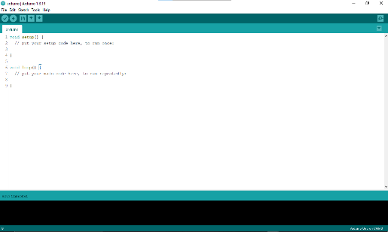

The Arduino IDE

The Arduino IDE is incredibly minimalistic, yet it provides a near-complete environment for most Arduino-based projects. The top menu bar has the standard options, including “File” (new, load save, etc.), “Edit” (font, copy, paste, etc.), “Sketch” (for compiling and programming), “Tools” (useful options for testing projects), and “Help”. The middle section of the IDE is a simple text editor that where you can enter the program code. The

bottom section of the IDE is dedicated to an output window that is used to see the status of the compilation, how much memory has been used, any errors that were found in the program, and various other useful messages.
Projects made using the Arduino are called sketches, and such sketches are usually written in a cut-down version of C++ (a number of C++ features are not included). Because programming a microcontroller is somewhat different from programming a computer, there are a number of device-specific libraries (e.g., changing pin modes, output data on pins, reading analog values, and timers). This sometimes confuses users who think Arduino is programmed in an “Arduino language.” However, the Arduino is, in fact, programmed in C++. It just uses unique libraries for the device.
The Arduino Integrated Development Environment - or Arduino Software (IDE) - contains a text editor for writing code, a message area, a text console, a toolbar with buttons for common functions and a series of menus. It connects to the Arduino and Genuino hardware to upload programs and communicate with them.
Programs written using Arduino Software (IDE) are called sketches. These sketches are written in the text editor and are saved with the file extension .ino. The editor has features for cutting/pasting and for searching/replacing text. The message area gives feedback while saving and exporting and also displays errors. The console displays text output by the Arduino Software (IDE), including complete error messages and other information. The bottom righthand corner of the window displays the configured board and serial port. The toolbar buttons allow you to verify and upload programs, create, open, and save sketches, and open the serial monitor.

LIBRARIES

Libraries provide extra functionality for use in sketches, e.g. working with hardware or manipulating data. To use a library in a sketch, select it from the Sketch > Import Library menu. This will insert one or more #include statements at the top of the sketch and compile the library with your sketch. Because libraries are uploaded to the board with your sketch, they increase the amount of space it takes up. If a sketch no longer needs a library, simply delete its #include statements from the top of your code.

There is a list of libraries in the reference. Some libraries are included with the Arduino software. Others can be downloaded from a variety of sources or through the Library Manager. Starting with version 1.0.5 of the IDE, you do can import a library from a zip file and use it in an open sketch.

CONNECTING THE ARDUINO
Connecting an Arduino board to your PC is quite simple. On Windows:
- Plug in the USB cable - one end to the PC, and one end to the Arduino board.
- When prompted, select "Browse my computer for driver" and then select the folder to which you extracted your original Arduino IDE download.
- You may receive an error that the board is not a Microsoft certified device - select “Install anyway.”
- Your board should now be ready for programming.
When programming your Arduino board it is important to know what COM port the Arduino is using on your PC. On Windows, navigate to Start->Devices and Printers, and look for the Arduino. The COM port will be displayed underneath.
Alternatively, the message telling you that the Arduino has been connected successfully in the lower-left hand corner of your screen usually specifies the COM port is it using.

PREPARING THE BOARD
Before loading any code to your Arduino board, you must first open the IDE. Double click the Arduino .exe file that you downloaded earlier. A blank program, or "sketch," should open.
The Blink example is the easiest way to test any Arduino board. Within the Arduino window, it can be found under File->Examples->Basics->Blink.
Before the code can be uploaded to your board, two important steps are required.

- Select your Arduino from the list under Tools->Board. The standard board used in RBE 1001, 2001, and 2002 is the Arduino Mega 2560, so select the "Arduino Mega 2560 or Mega ADK" option in the dropdown.
- Select the communication port, or COM port, by going to Tools->Serial Port.
If you noted the COM port your Arduino board is using, it should be listed in the dropdown menu. If not, your board has not finished installing or needs to be reconnected.

LOADING CODE
The upper left of the Arduino window has two buttons: A checkmark to Verify your code, and a right-facing arrow to Upload it. Press the right arrow button to compile and upload the Blink example to your Arduino board.
The black bar at the bottom of the Arduino window is reserved for messages indicating the success or failure of code uploading. A "Completed Successfully" message should appear once the code is done uploading to your board. If an error message appears instead, check that you selected the correct board and COM port in the Tools menu, and check your physical connections.
If uploaded successfully, the LED on your board should blink on/off once every second.
Most Arduino boards have an LED prewired to pin 13.
It is very important that you do not use pins 0 or 1 while loading code. It is recommended that you do not use those pins ever.
Arduino code is loaded over a serial port to the controller. Older models use an FTDI chip which deals with all the USB specifics. Newer models have either a small AVR that mimics the FTDI chip or a built-in USB-to-serial port on the AVR micro-controller itself.

PROTEUS

Proteus Virtual System Modelling (VSM) is an advanced software tool that stands out in the realm of embedded system simulation. Its ability to accurately mimic the interactions between software running on microcontrollers and both analogue and digital devices is pivotal for engineers and developers. Here’s a deeper dive into the features, capabilities, and advantages of using Proteus VSM in product design and development.

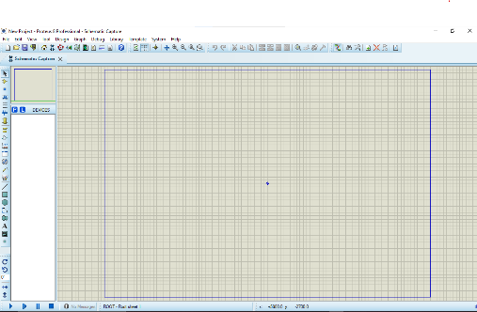

Key Features of Proteus VSM

Comprehensive Microcontroller Support: Proteus VSM supports over 750 different microcontroller types, including popular families such as PIC, AVR, ARM, and more. This extensive support allows engineers to work with the specific hardware they intend to use, ensuring that the simulation reflects real-world performance accurately.
Real-Time Simulation: Unlike basic simulation tools, Proteus VSM emulates the execution of object code in real-time. This means that when a program writes to a port, the corresponding logic levels in the circuit change instantaneously, allowing for dynamic interactions that mirror physical hardware behavior.
Detailed Peripheral Emulation: Proteus VSM doesn’t just simulate the microcontroller; it also fully emulates all associated peripherals. This includes:
I/O Ports: Each port's behavior is accurately modeled, reflecting how they would interact in a physical circuit.
Interrupts: The handling of interrupts is simulated, allowing developers to see how their code responds to external events.
Timers: Accurate timer emulation enables testing of time-sensitive applications.

USARTs and Communication Protocols: Proteus VSM supports a variety of communication protocols, making it easier to develop systems that rely on serial communication.

SPICE Simulation Integration: Proteus incorporates a library of hundreds of embedded SPICE models, enabling users to simulate complex electronic circuits. This integration allows for detailed analysis of circuit behavior under various conditions, facilitating thorough testing before hardware implementation.
Extensive Component Library: With one of the largest libraries of embedded simulation peripherals, users can find components ranging from basic resistors and capacitors to complex sensors and actuators. This vast library simplifies the process of building and testing sophisticated embedded systems.

Advantages of Using Proteus VSM

Cost and Time Efficiency: By enabling virtual testing and debugging, Proteus VSM significantly reduces the need for physical prototypes. This not only cuts down costs associated with materials and manufacturing but also accelerates the development process, allowing for faster iterations and adjustments.
Enhanced Debugging Capabilities: The real-time nature of the simulation allows developers to debug their code interactively. Users can observe the effects of their code changes immediately, facilitating a more intuitive debugging process compared to traditional methods.
Educational Tool: Proteus VSM is widely used in academic settings to teach embedded systems and electronics. Its visual representation of circuits and intuitive interface make it an excellent tool for students to grasp complex concepts in a practical context.
Integration with Development Environments: Proteus VSM can be easily integrated with various Integrated Development Environments (IDEs), enhancing workflow efficiency. This compatibility ensures that developers can work within their preferred environments while leveraging the robust simulation capabilities of Proteus.
User-Friendly Interface: The software boasts an intuitive graphical user interface (GUI) that simplifies the process of designing circuits and programming microcontrollers. Users can easily drag and drop components, create connections, and visualize their designs without extensive training.

Applications of Proteus VSM

- Proteus VSM is versatile and can be applied across numerous fields, including:
- Consumer Electronics: Rapid prototyping of devices like remote controls, smart home systems, and wearable technology.
- Industrial Automation: Testing control systems, sensors, and actuators before deployment in manufacturing environments.
- Automotive Systems: Simulating embedded systems in vehicles for safety and performance optimization.
- Medical Devices: Ensuring reliability and compliance in the design of diagnostic and therapeutic equipment.

CHAPTER 5 SYSTEM DESIGN

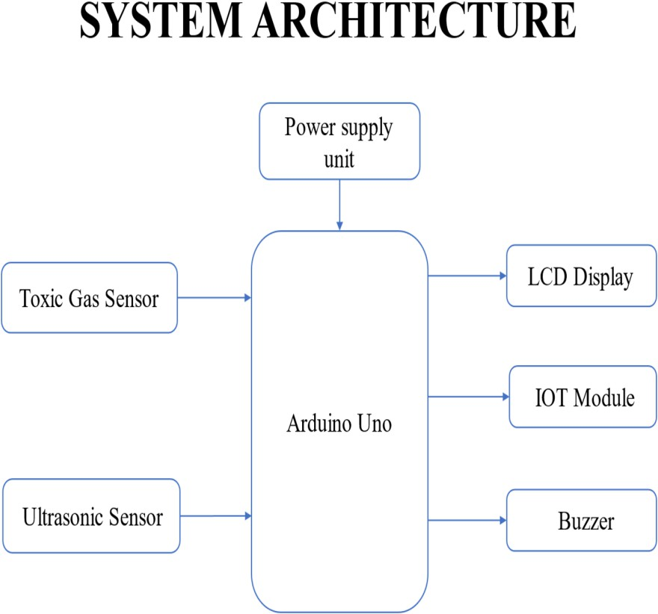

CIRCUIT DIAGRAM EXPLANATION:

Module Explanation

Ultrasonic Sensor Module

The ultrasonic sensor module is an essential component of the system, designed to monitor the water levels within drainage channels in real time. The working principle of the ultrasonic sensor is based on the emission of sound waves, which travel through the air and bounce back after striking an object (in this case, the surface of the water). The sensor calculates the distance to the water surface based on the time it takes for the sound waves to return, and this measurement is used to determine the water level. As water levels rise beyond certain thresholds, this could indicate potential blockages or overflow situations. Regular monitoring of water levels helps prevent these problems before they escalate, allowing for early intervention by maintenance teams. By implementing this sensor, the system ensures that the drainage system operates within safe limits,

reducing the risk of environmental damage, waterlogging, and public health issues caused by overflowing drains.

The Toxic Gas Detection:

The toxic gas detection module is crucial for ensuring the safety of workers who maintain drainage systems. Drainage systems, especially in urban areas, can trap gases like methane (CH₄), hydrogen sulfide (H₂S), and ammonia (NH₃), which are dangerous to human health. Methane is flammable, while hydrogen sulfide has a toxic, corrosive odor that can cause respiratory problems and even fatalities in high concentrations. The gas sensors used in this module are capable of detecting the presence and concentration of these gases. The sensors, typically part of the MQ-series, work by sensing the chemical compounds in the air and generating a signal that is sent to the microcontroller. The microcontroller processes the data and, if gas concentrations exceed safe levels, triggers an alert. This early detection is vital for preventing accidents by warning workers before they enter potentially hazardous environments. Additionally, this module contributes to public safety by preventing toxic gas leaks that could affect nearby residents.

IoT Communication Module

The IoT communication module, commonly based on platforms like ESP32 or NodeMCU, forms the backbone of the system's remote monitoring capabilities. This module serves to connect all the sensors in the system (e.g., ultrasonic and gas detection) to a centralized cloud platform or local server. It allows for the continuous transmission of sensor data, enabling the monitoring of drainage conditions in real time from anywhere with internet connectivity. The module uses Wi- Fi to send data, and through IoT protocols, the system updates the status of the drainage infrastructure on a dashboard, which can be accessed by city maintenance teams, public officials, or other relevant stakeholders. In addition to sending real-time updates, the IoT module can log historical data, providing valuable insights into the system's performance over time. This data is crucial for predicting maintenance needs, analyzing trends, and improving the long-term management of urban drainage systems. The module ensures that intervention can be swift, based on up-to-date information, and helps in making data-driven decisions that improve system efficiency and public safety.

LCD Display Module

The LCD display module provides a direct, local interface for on-site monitoring of the drainage system's status. It displays real-time data on parameters such as water levels, gas concentrations, and system health. This local display is beneficial for technicians who need to make quick assessments when working on-site without needing a mobile device or internet connection. For example, during routine inspections or emergency maintenance, the LCD can show whether water levels are within normal limits or if toxic gases are present. This ensures that workers are always aware of critical conditions, allowing them to act swiftly if problems are detected. The display also improves system transparency, providing immediate visual feedback on the operational status of the drainage system. It complements the IoT-based remote monitoring system, providing a localized solution that is especially useful in situations where the network is down or when a technician needs to inspect individual sensor modules directly

Buzzer Alert Module

The buzzer alert module is a critical safety feature of the system that provides immediate audible warnings when conditions in the drainage system reach critical thresholds. For instance, when the ultrasonic sensor detects dangerously high water levels or the gas detection module identifies toxic gas concentrations, the microcontroller activates the buzzer. This alert is loud enough to catch the attention of nearby personnel, ensuring that critical issues are promptly addressed. The buzzer plays a crucial role in reducing response times, as it provides an immediate, tangible signal of impending hazards. This is particularly important in situations where workers may not be actively monitoring data on an LCD or a mobile device and need an instant, attention-grabbing alert. By alerting workers and bystanders, the buzzer helps prevent serious accidents, such as drowning from an overflow or exposure to harmful gases, ensuring the overall safety of workers and residents.

Microcontroller Unit (MCU)

The microcontroller unit (MCU), such as the Arduino Uno or ESP32, is the brain of the entire system. It acts as the central processing unit, orchestrating communication between all the connected modules. The MCU reads sensor data from the ultrasonic and gas sensors, processes it based on predefined conditions or thresholds, and triggers appropriate actions—whether it's sending data to the cloud, displaying information on the LCD, or activating the buzzer. In addition to handling the inputs and outputs, the microcontroller also manages the timing and coordination of various system tasks, ensuring smooth operation of the drainage monitoring network. It can also

be programmed to handle advanced logic, such as initiating automatic maintenance routines or adjusting sensor thresholds based on environmental factors. The microcontroller ensures that the system remains responsive, reliable, and scalable, capable of handling multiple sensors in complex urban drainage networks. By integrating the microcontroller into the system, it ensures seamless data flow and real-time monitoring, making the system robust and effective in addressing drainage- related issues.

HARDWARE IMPLEMENTATION

ARDUINO UNO

The Arduino UNO is an open-source microcontroller board based on the Microchip ATmega328P microcontroller and developed by Arduino.cc. The board is equipped with sets of digital and analog input/output (I/O) pins that may be interfaced to various expansion boards (shields) and other circuits. The board has 14 Digital pins, 6 Analog pins, and programmable with the Arduino IDE (Integrated Development Environment) via a type B USB cable. It can be powered by a USB cable or by an external 9 volt battery, though it accepts voltages between 7 and 20 volts. It is also similar to the Arduino Nano and Leonardo. The hardware reference design is distributed under a Creative Commons Attribution Share-Alike 2.5 license and is available on the Arduino website. Layout and production files for some versions of the hardware are also available. "Uno" means one in Italian and was chosen to mark the release of Arduino Software (IDE) 1.0. The Uno board and version 1.0 of Arduino Software (IDE) were the reference versions of Arduino, now evolved to newer releases. The Uno board is the first in a series of USB Arduino boards, and the reference model for the Arduino platform. The ATmega328 on the Arduino Uno comes preprogrammed with a boot loader that allows uploading new code to it without the use of an external hardware programmer. It communicates using the original STK500 protocol. The Uno also differs from all preceding boards in that it does not use the FTDI USB-to-serial driver chip. Instead, it uses the Atmega16U2 (Atmega8U2 up to version R2) programmed as a USB-to-serial converter

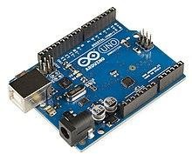

The Arduino project started at the Interaction Design Institute Ivrea (IDII) in Ivrea, Italy. At that time, the students used a BASIC Stamp microcontroller at a cost of $100, a considerable expense for many students. In 2003 Hernando Barragán created the development platform Wiring as a Master's thesis project at IDII, under the supervision of Massimo Banzi and Casey Reas, who are known for work on the Processing language. The project goal was to create simple, low-cost tools for creating digital projects by non-engineers. The Wiring platform consisted of a printed circuit board (PCB) with an ATmega168 microcontroller, an IDE based on Processing and library functions to easily program the microcontroller. In 2003, Massimo Banzi, with David Mellis, another IDII student, and David Cuartielles, added support for the cheaper ATmega8 microcontroller to Wiring. But instead of continuing the work on Wiring, they forked the project and renamed it Arduino. Early arduino boards used the FTDI USB-to-serial driver chip and an ATmega168. The Uno differed from all preceding boards by featuring the ATmega328P microcontroller and an ATmega16U2 (Atmega8U2 up to version R2) programmed as a USB-to- serial converter.
SPECIFICATION

- Microcontroller: Microchip ATmega328P
- Operating Voltage: 5 Volt
- Input Voltage: 7 to 20 Volts
- Digital I/O Pins: 14 (of which 6 provide PWM output)
- Analog Input Pins: 6
- DC Current per I/O Pin: 20 mA
- DC Current for 3.3V Pin: 50 mA

- Flash Memory: 32 KB of which 0.5 KB used by boot loader
- SRAM: 2 KB
- EEPROM: 1 KB
- Clock Speed: 16 MHz
- Length: 68.6 mm
- Width: 53.4 mm
- Weight: 25 g

COMMUNICATION

The Arduino/Genuino Uno has a number of facilities for communicating with a computer, another Arduino/Genuino board, or other microcontrollers. The ATmega328 provides UART TTL (5V) serial communication, which is available on digital pins 0 (RX) and 1 (TX). An ATmega16U2 on the board channels this serial communication over USB and appears as a virtual com port to software on the computer. The 16U2 firmware uses the standard USB COM drivers, and no external driver is needed. However, on Windows, a .inf file is required. The Arduino Software (IDE) includes a serial monitor which allows simple textual data to be sent to and from the board. The RX and TX LEDs on the board will flash when data is being transmitted via the USB-to-serial chip and USB connection to the computer (but not for serial communication on pins 0 and 1). A Software Serial library allows serial communication on any of the Uno's digital pins

PINS General Pin functions

  - LED: There is a built-in LED driven by digital pin 13. When the pin is HIGH value, the LED is on, when the pin is LOW, it's off.
  - VIN: The input voltage to the Arduino/Genuino board when it's using an external power source (as opposed to 5 volts from the USB connection or other regulated power source). You can supply voltage through this pin, or, if supplying voltage via the power jack, access it through this pin.
  - 5V: This pin outputs a regulated 5V from the regulator on the board. The board can be supplied with power either from the DC power jack (7 - 20V), the USB connector (5V), or the VIN pin of the board (7-20V). Supplying voltage via the 5V or 3.3V pins bypasses the regulator, and can damage the board.

  - 3V3: A 3.3 volt supply generated by the on-board regulator. Maximum current draw is 50 mA.
  - GND: Ground pins.
  - IOREF: This pin on the Arduino/Genuino board provides the voltage reference with which the microcontroller operates. A properly configured shield can read the IOREF pin voltage and select the appropriate power source or enable voltage translators on the outputs to work with the 5V or 3.3V.
  - Reset: Typically used to add a reset button to shields which block the one on the board.

Special Pin Functions

Each of the 14 digital pins and 6 Analog pins on the Uno can be used as an input or output, using pinMode (), digitalWrite(), and digitalRead() functions. They operate at 5 volts. Each pin can provide or receive 20 mA as recommended operating condition and has an internal pull-up resistor (disconnected by default) of 20-50k ohm. A maximum of 40mA is the value that must not be exceeded on any I/O pin to avoid permanent damage to the microcontroller. The Uno has 6 analog inputs, labeled A0 through A5, each of which provide 10 bits of resolution (i.e. 1024 different values). By default they measure from ground to 5 volts, though is it possible to change the upper end of their range using the AREF pin and the analogReference() function.
In addition, some pins have specialized functions:

  - Serial / UART: pins 0 (RX) and 1 (TX). Used to receive (RX) and transmit (TX) TTL serial data. These pins are connected to the corresponding pins of the ATmega8U2 USB-to-TTL Serial chip.
  - External Interrupts: pins 2 and 3. These pins can be configured to trigger an interrupt on a low value, a rising or falling edge, or a change in value.
  - PWM (Pulse Width Modulation): 3, 5, 6, 9, 10, and 11 Can provide 8-bit PWM output with the analogWrite () function.
  - SPI (Serial Peripheral Interface): 10 (SS), 11 (MOSI), 12 (MISO), 13 (SCK). These pins support SPI communication using the SPI library.

  - TWI (Two Wire Interface) / I²C: A4 or SDA pin and A5 or SCL pin. Support TWI communication using the Wire library.
  - AREF (Analog REFerence): Reference voltage for the analog inputs

NODEMCU (ESP8266)

The ESP8266 is a low-cost, highly integrated Wi-Fi chip that has become one of the most popular choices for Internet of Things (IoT) applications. Developed by Espressif Systems, it offers Wi-Fi capabilities to embedded systems at an affordable price, making it an excellent choice for hobbyists, makers, and developers building connected devices. Whether it’s a simple home automation system, a weather station, or an industrial IoT device, the ESP8266 can handle a variety of tasks and is supported by a large community of developers.
In this guide, we’ll go over a detailed explanation of the ESP8266 chip, its specifications, pin configuration, and common applications, giving you a comprehensive understanding of this powerful IoT tool.
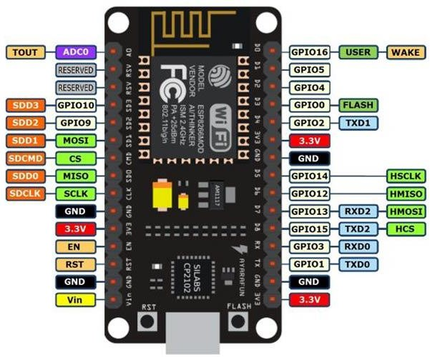

INTRODUCTION TO ESP8266

The ESP8266 is a 32-bit RISC-based microcontroller with an integrated Wi-Fi module. Espressif designed this chip with the goal of providing a low-cost yet highly functional platform for embedding wireless internet connectivity into everyday devices. This chip offers a combination of Wi-Fi communication, processing power, and a flexible input/output interface, all packed into a small form factor, making it ideal for embedded systems and IoT devices.
Originally, the ESP8266 was used primarily as a Wi-Fi module that could connect to a host microcontroller, but with the introduction of the ESP-12 and ESP-01 modules, it became a standalone microcontroller capable of running user applications. It operates in client mode (connecting to a Wi-Fi network) as well as access point mode (creating its own Wi-Fi network).
The versatility and functionality of the ESP8266, coupled with its low cost and ease of use, have made it a go-to solution for a wide range of applications. It is supported by numerous development environments and libraries, making it beginner-friendly while still being powerful enough for advanced projects.

SPECIFICATIONS OF THE ESP8266

The ESP8266 is a highly capable microcontroller with a set of impressive specifications, making it suitable for IoT applications. Below is a detailed breakdown of the ESP8266's specifications:

Processor and Performance

  - Architecture: 32-bit RISC processor.
  - Clock Speed: Typically runs at 80 MHz, though some models support up to 160 MHz.
  - Flash Memory: The ESP8266 typically comes with 1 MB to 16 MB of Flash memory, depending on the variant.
  - RAM: The chip contains 64 KB of instruction RAM and 96 KB of data RAM for executing applications.
  - CPU: The ESP8266 features a Tensilica L106 microprocessor.

Wireless Connectivity

  - Wi-Fi Standard: 802.11 b/g/n with support for both Station (STA) and Access Point (AP) modes.
  - Wi-Fi Speed: It supports speeds up to 72.2 Mbps in 802.11n mode.

  - Security: Supports WEP, WPA, and WPA2 security protocols.
  - Frequency Range: Operates in the 2.4 GHz band.

I/O Capabilities

  - GPIO Pins: Depending on the module (e.g., ESP-12, NodeMCU), the ESP8266 has up to 17 GPIO pins.
  - These pins can be configured for digital input/output, PWM, I2C, SPI, ADC (Analog-to- Digital Conversion), and interrupts.
  - ADC: The chip has a 10-bit ADC (Analog to Digital Converter) with a maximum voltage range of 1V.
  - UART: The ESP8266 supports two UART interfaces for serial communication.
  - PWM: Pulse-width modulation (PWM) can be used for controlling motor speed or brightness of LEDs.
  - SPI/I2C: The chip also supports SPI and I2C communication protocols, allowing easy interfacing with sensors and peripherals.

Power Consumption

Operating Voltage: The ESP8266 operates at 3.3V, and care must be taken not to apply voltages higher than 3.3V to any of its pins.
Power Consumption: It is designed to be energy-efficient, with deep sleep and modem sleep modes available, which reduce power consumption significantly.
Typical Current Consumption:

Active Mode: 80mA - 200mA (depending on the Wi-Fi activity). Deep Sleep: ~20µA.

PROGRAMMING AND DEVELOPMENT

Development Platforms: The ESP8266 is most commonly programmed using the Arduino IDE, which offers a wide range of libraries and examples to get started quickly. The chip can also be programmed using other development environments such as MicroPython, NodeMCU (Lua), or PlatformIO.
Built-in Flash: The chip typically comes with 1MB to 16MB flash memory, enabling storage for both the application and Wi-Fi firmware.

ESP8266 PINOUT AND GPIO CONFIGURATION

The pinout for the ESP8266 can vary depending on the specific module, such as the ESP-01, ESP- 12, or NodeMCU development board. The following is a general pin description for the ESP-12 module, one of the most popular variants.
ESP8266 Pin Description (ESP-12)

GPIO0 (D3): Used as a digital I/O pin or for boot mode selection. GPIO1 (TX): UART Transmit (TX) pin for serial communication. GPIO2 (D4): Digital I/O pin, also used for PWM output.
GPIO3 (RX): UART Receive (RX) pin for serial communication. GPIO4 (D2): Digital I/O pin, can be used with I2C or PWM. GPIO5 (D1): Another digital I/O pin, typically used for I2C or SPI. GPIO6: Flash Memory pin, typically not used for general I/O.
GPIO7: Digital I/O pin, used for general purposes or in SPI communication. GPIO8: Similar to GPIO6 and 7, used for Flash Memory.
GPIO9: Often used for Flash purposes, typically not used for general I/O. GPIO10: Same as GPIO9, used for Flash Memory.
GPIO11: Flash Control, not usually available for general-purpose I/O. VCC: 3.3V power supply pin.

GND: Ground pin.

RST: Reset pin, used to reset the chip.

CH_PD (EN): Chip enable pin, needs to be pulled high to enable the chip. ADC (A0): Analog-to-Digital Converter input pin (max 1V).

APPLICATIONS OF THE ESP8266

The ESP8266 has revolutionized IoT applications due to its flexibility, low cost, and Wi-Fi connectivity. Below are some of the most common applications of the ESP8266:

Home Automation

The ESP8266 is ideal for home automation systems, where it can be used to control appliances like lights, fans, thermostats, and even security systems. With Wi-Fi capabilities, the ESP8266 allows users to control their devices remotely through smartphones or web-based interfaces. Integration with popular platforms like Google Home or Amazon Alexa is also possible, allowing voice control of the devices.

Smart Sensors and Monitoring Systems

One of the most common uses of the ESP8266 is in sensor-based systems. It can interface with various sensors such as temperature and humidity sensors, gas detectors, motion sensors, and light sensors. Data from these sensors can be transmitted via Wi-Fi to a central server, cloud platform, or mobile app, allowing real-time monitoring and analysis.

Weather Stations

ESP8266 is widely used in creating wireless weather stations, where it can collect data from sensors like temperature, humidity, barometric pressure, and rainfall. This data can be uploaded to a cloud service like Thing Speak, allowing users to visualize the data online or via apps.

Industrial IoT (IIoT)

The ESP8266 is also employed in industrial applications, where it can be used to monitor equipment, detect faults, and control machinery remotely. This allows businesses to streamline operations, perform predictive maintenance, and enhance operational efficiency.

Wearables and Health Devices

The chip can be used in wearable devices to collect health metrics like heart rate, temperature, and activity levels. These devices can transmit data to smartphones or cloud servers, providing real- time insights into the user's health.

Security Systems

Security systems such as smart locks, surveillance cameras, and motion sensors frequently utilize the ESP8266 for remote control and monitoring. The Wi-Fi connectivity allows the user to access the system through mobile apps or web interfaces, providing security solutions for homes and businesses.

POWER SUPPLY

The 7812 and 7805 voltage regulators are commonly used components to provide stable DC voltage outputs of +12V and +5V, respectively, from a higher input voltage source.
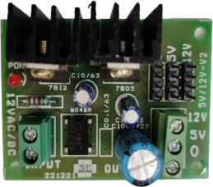

7812 Voltage Regulator:

Input Voltage: Typically requires an input voltage slightly higher than 12V (usually around 14- 16V) to regulate effectively.
Output Voltage: Provides a stable +12V DC output.

Capacitors:

C1000/25: This likely refers to a capacitor with a capacitance of 1000µF and a voltage rating of 25V. This capacitor is typically placed on the input side (between input and ground) to stabilize the input voltage, reducing noise and providing a reservoir of charge to handle transient spikes.
C10/63: This could refer to a capacitor with a capacitance of 10µF and a voltage rating of 63V. This capacitor is usually placed on the output side (between output and ground) to stabilize the output voltage, filtering out any remaining noise and improving regulation.
Resistor: A resistor isn’t typically used directly with the 7812 regulator in the same way as capacitors are, but it can be part of the circuit design for specific applications, such as in voltage dividers or as part of a feedback loop for stability.

7805 Voltage Regulator:

Input Voltage: Requires an input voltage typically around 7-25V (ideal 7-20V) to regulate effectively.
Output Voltage: Provides a stable +5V DC output.

Capacitors:

C1000/25: As with the 7812, this capacitor stabilizes the input voltage to the regulator. C10/63: This capacitor stabilizes the output voltage of the regulator.
Resistor: Similar to the 7812, resistors are not directly part of the typical configuration but can be used in specific applications.
Circuit Considerations:

Decoupling Capacitors: These capacitors (like C1000/25 and C10/63) are crucial for filtering out noise and stabilizing the voltage levels, ensuring reliable operation of your circuit.
Heat Dissipation: Both regulators can generate heat, especially when dropping significant voltage. Adequate heat sinking may be necessary depending on the current drawn and the input-output voltage differential.

Current Requirements: Ensure that the regulators can supply enough current for your application. If higher currents are required, additional heat sinking and possibly parallel regulators may be needed.
In summary, the 7812 and 7805 voltage regulators, along with capacitors like C1000/25 and C10/63, form a basic yet effective setup for providing stable +12V and +5V outputs in electronic circuits, suitable for a wide range of applications from powering microcontrollers to analog circuits.

LIQUID CRYSTAL DISPLAY
A liquid crystal display (LCD) is a flat panel display, electronic visual display, or video display that uses the light modulating properties of liquid crystals. Liquid crystals do not emit light directly. LCDs are available to display arbitrary images (as in a general-purpose computer display) or fixed images which can be displayed or hidden, such as preset words, digits, and 7- segment displays as in a digital clock. They use the same basic technology, except that arbitrary images are made up of a large number of small pixels, while other displays have larger elements. An LCD is a small low cost display. It is easy to interface with a micro-controller because of an embedded controller (the black blob on the back of the board). This controller is standard across many displays (HD 44780) which means many micro-controllers (including the Arduino) have libraries that make displaying messages as easy as a single line of code.
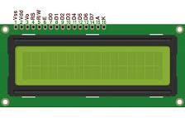

LCD display unit
LCDs are used in a wide range of applications including computer monitors, televisions, instrument panels, aircraft cockpit displays, and signage. They are common in consumer devices such as video players, gaming devices, clocks, watches, calculators, and telephones, and have replaced cathode ray tube (CRT) displays in most applications. They are available in a wider range

of screen sizes than CRT and plasma displays, and since they do not use phosphors, they do not suffer image burn-in. LCDs are, however, susceptible to image persistence.

16X2 LCD SPECIFICATIONS

- Display Format: 16 characters per line, 2 lines total.
- Character Size: 5x8 pixels for standard characters.
- Dimensions: Approximately 80mm x 36mm x 13mm.
- Interface: Parallel (4-bit or 8-bit mode).
- Supply Voltage: Typically 5V DC.
- Current Consumption: Around 1.5 mA at 5V.
- Backlight: LED backlight (3.3V to 5V).
- Temperature Range: 0°C to 70°C operating, -20°C to 80°C storage.
- Response Time: Under 10 ms.
- Mounting: PCB or breadboard compatible.
- Character Set: Standard ASCII with custom character support.

I2C (Inter-Integrated Circuit)

The I2C connection for an LCD display enables efficient and simplified interfacing with microcontrollers, like the ESP32, by requiring only two data lines: SDA (data) and SCL (clock). This setup significantly reduces the number of pins needed, compared to traditional parallel connections, allowing other I/O pins on the microcontroller to remain free for additional sensors or peripherals. The I2C interface is controlled by a small I2C module on the back of the LCD, typically using a chip like the PCF8574, which converts the I2C signals into parallel signals the LCD can interpret. Each device on the I2C bus has a unique address (e.g., 0x27 for many LCD modules), letting the microcontroller communicate with specific devices even if there are multiple I2C components on the same bus. The power (VCC) and ground (GND) lines complete the connections, and the data transfer is synchronous, meaning the microcontroller (master) sends commands in sync with the LCD (slave). Commands like positioning the cursor, clearing the display, or updating text are all handled through simple I2C libraries that streamline programming.

This makes I2C ideal for projects that require organized wiring and efficient communication, especially in setups where pin limitations and space are considerations.
BUZZER:
A "buzzer sensor" typically refers to an electronic component that includes a buzzer integrated with additional circuitry to enable it to be controlled or triggered by an external signal.

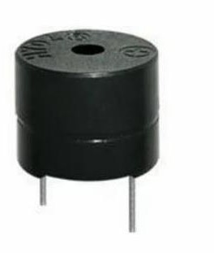

Pin Configuration:

Magnetic Buzzer (Active Buzzer):

- Connect the positive leg of the buzzer to a digital output pin (e.g., pin 9) on the Arduino.
- Connect the negative leg of the buzzer to the GND pin on the Arduino.
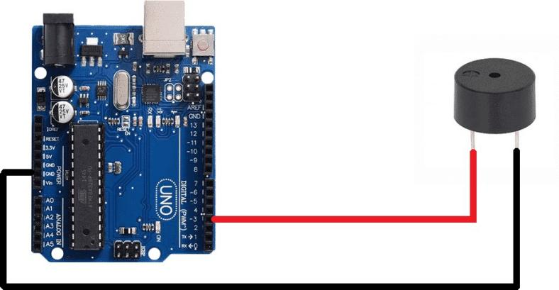

Applications

- Indication and Alerts: Used in electronic devices and systems to provide audible feedback, alerts, or warnings. For example, in alarm systems, timers, and notification devices.

- User Interaction: Incorporated into user interfaces to provide feedback for button presses, actions, or system status.
- Testing and Troubleshooting: Used in testing and troubleshooting scenarios to provide audible feedback for diagnostics and operational status.
- Games and Entertainment: Integrated into games, toys, and entertainment devices to provide sound effects and enhance user experience.

ULTRASONIC SENSOR:
An ultrasonic sensor is a device that uses sound waves to measure the distance to an object. It emits an ultrasonic pulse and measures the time it takes for the pulse to reflect back from the object. By calculating the time delay, it determines the distance between the sensor and the object.
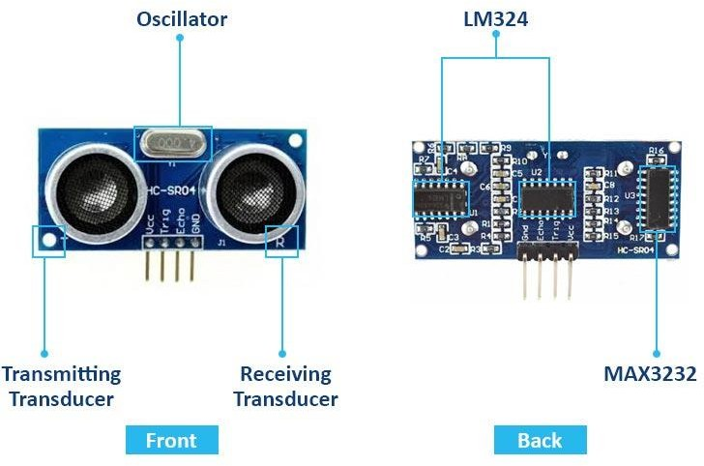

WORKING PRINCIPLE OF ULTRASONIC SENSOR

An ultrasonic sensor works by emitting high-frequency sound waves, typically beyond the range of human hearing, and measuring the time it takes for these waves to travel to an object and bounce back. The sensor consists of a transmitter that sends out an ultrasonic pulse and a receiver that detects the reflected sound waves. When the sensor emits the sound wave, it travels through the air until it encounters an object, which reflects the wave back to the sensor. The

sensor measures the time it takes for the sound to travel to the object and return. Using the speed of sound in air, the sensor calculates the distance to the object. The formula used is:

Distance = Speed of Sound × Time 2
The factor of 2 accounts for the round trip of the sound wave. By processing the time and the known speed of sound, the sensor can determine the precise distance between itself and the object. This non-contact measurement method makes ultrasonic sensors valuable in a wide range of applications, such as obstacle detection, distance measurement, and level sensing.

PIN CONFIGURATION OF ULTRASONIC SENSOR

A common ultrasonic sensor is the HC-SR04. Below is its typical pin configuration:

VCC | Power supply pin (typically +5V).
Trig (Trigger): | Sends a 10 µs HIGH pulse to start the ultrasonic  wave.
Echo | Outputs a HIGH signal with duration  proportional to the return time of the wave.
GND | Ground pin for the sensor.

SPECIFICATIONS OF ULTRASONIC SENSORS

Operating Voltage: 5V DC

Max Current Consumption: ~15 mA during normal operation (up to 50 mA during transmission) Operating Frequency: 40 kHz
Range: 2 cm to 400 cm (0.02 m to 4 m)

Accuracy: ±3 mm

Resolution: 1 cm (0.01 m) Beam Angle: About 15 degrees

Response Time: Around 10 ms

Output Type: Digital (Echo pin outputs a HIGH signal, the pulse width corresponds to distance)

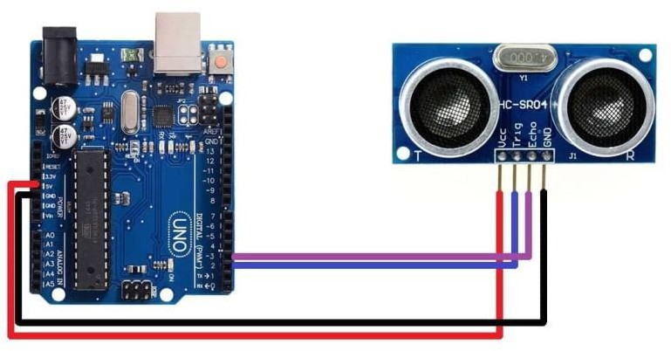

APPLICATIONS OF ULTRASONIC SENSORS

  - Robotics: Used in robots for obstacle detection, mapping surroundings, and navigation.
  - Automotive: In parking sensors for distance measuring to prevent collisions.
  - Industrial Automation: For distance measurement in conveyor belts, material handling, and robotic arms.
  - Water Level Measurement: Used in tanks, wells, and reservoirs to monitor water levels.
  - Gesture Recognition: Detecting hand or body gestures in interactive systems.
  - Medical: Ultrasonic sensors are used in medical devices for measurements and imaging, like in ultrasound imaging.
  - Security Systems: For motion detection or perimeter monitoring.

GAS SENSOR:
A gas sensor is a device that detects and measures the concentration of gases in the air. These sensors are widely used in various industries for safety, environmental monitoring, and process control.

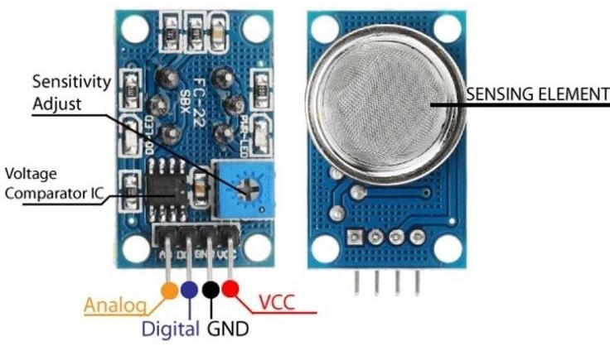

Detection Principle:

Gas sensors work by detecting the presence and concentration of specific gases in the air. They often rely on chemical reactions or physical changes that occur when a target gas is present.

Key Features:

  - Sensitivity: Ability to detect low concentrations of gases.
  - Selectivity: Ability to detect a specific gas in the presence of other gases.
  - Response Time: The time it takes for the sensor to respond to a change in gas concentration.
  - Range: The range of gas concentrations that the sensor can detect.
  - Stability and Lifetime: Long-term reliability and consistent performance over time.
  - Operating Temperature and Humidity: The environmental conditions in which the sensor can operate effectively.

Specifications:

  - Detection Range: The minimum and maximum gas concentrations the sensor can detect.
  - Resolution: The smallest change in gas concentration the sensor can detect.
  - Accuracy: The degree to which the sensor's measurements agree with the true gas concentration.
  - Power Consumption: The amount of power the sensor requires to operate.

Special Pin Functions:

VCC (Voltage Common Collector) | +5V
GND (Ground) | Ground of the power supply

AO (Analog Output) | Gas level measurement
DO (Digital Output) | Gas detected or Not

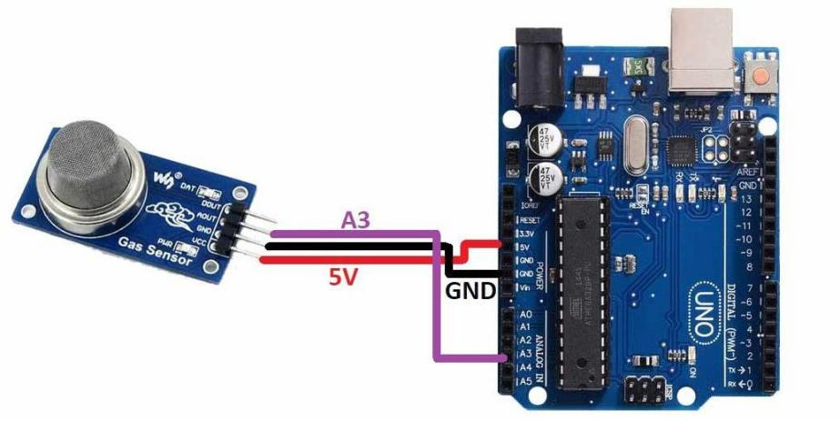

Applications:

  - Environmental Monitoring: Measuring air quality and detecting pollutants.
  - Industrial Safety: Detecting hazardous gases to prevent explosions or poisoning.
  - Medical Applications: Monitoring respiratory gases and anesthetic gases. Automotive Industry: Emission control and monitoring air quality inside vehicles.

SYSTEM TESTING
Results and Discussion
The implementation of the IoT-based drainage monitoring system has demonstrated significant improvements in the management of urban drainage networks. Through the use of ultrasonic sensors, the system has proven effective in detecting and monitoring wastewater levels, accurately identifying potential blockages before they lead to overflow. In pilot studies, the system was able to send early warnings, enabling proactive maintenance interventions, which reduced downtime and prevented major system failures. The real-time monitoring provided by the IoT-enabled sensors has also allowed for quicker identification of problem areas, ensuring that maintenance teams can address issues more efficiently, saving both time and resources.

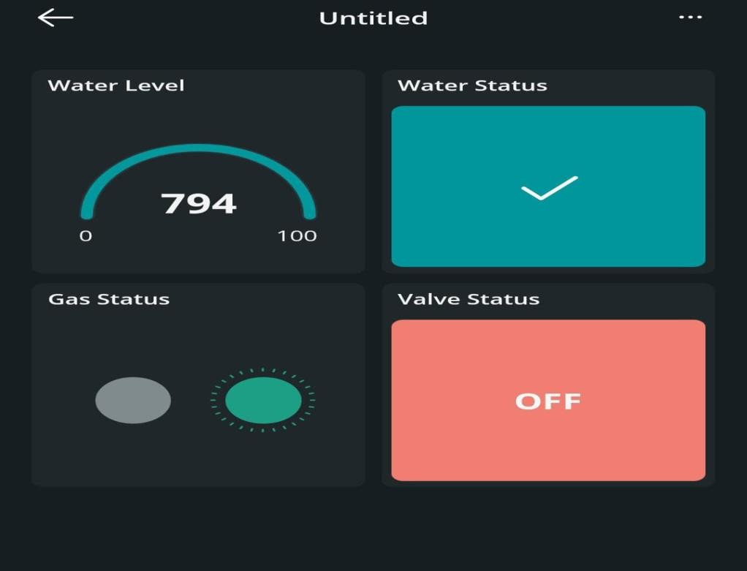

The integration of toxic gas detection modules has added an essential layer of safety to the system, protecting sanitation workers and residents from the risks associated with hazardous gases in drainage systems. The system's ability to detect gases such as methane and hydrogen sulfide, which are common byproducts of decomposing organic waste in drains, has been critical in preventing health hazards. By alerting operators to dangerous gas concentrations, the system ensures that timely action can be taken to mitigate risks.
Moreover, the continuous updates provided via LCD displays and IoT connectivity have enhanced visibility and decision-making for both field operators and central management teams. The real- time data is easily accessible, fostering transparency and enabling quick responses to emergencies. The automated buzzer alerts have also proven to be effective in drawing immediate attention to critical issues, allowing for faster resolution and minimizing potential damage to the drainage system.

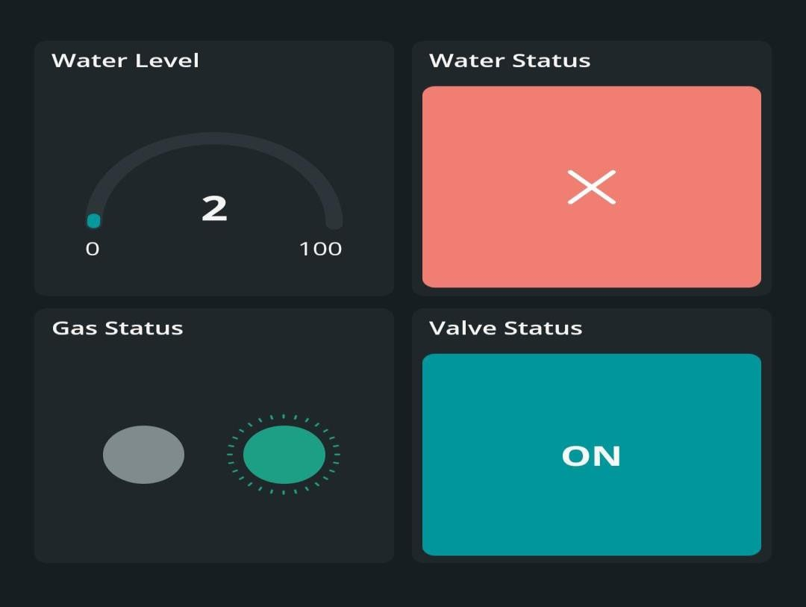

Overall, the system has demonstrated its capability to enhance public health and safety by preventing blockages, mitigating health risks, and improving overall drainage system management. The results suggest that IoT-based monitoring solutions offer a scalable, cost- effective approach for modernizing urban infrastructure and addressing the growing challenges posed by urbanization.

ARDUINO IOT CLOUD



Arduino IoT Cloud is a robust and versatile platform that enables users to develop, manage, and deploy Internet of Things (IoT) applications with ease. It is designed to integrate seamlessly with

Arduino boards and other compatible hardware, allowing makers, hobbyists, and developers to create connected devices and control them remotely through a straightforward, intuitive interface. By leveraging this platform, users can build projects that gather sensor data, trigger actions, and visualize information in real time from anywhere in the world. One of the defining aspects of Arduino IoT Cloud is its user-friendly design, which lowers the barrier to entry for IoT development. It provides a visual interface where users can create things, define variables, and link devices without extensive coding knowledge. This no-code or low-code approach makes the platform accessible to beginners while still being powerful enough for advanced users who want to dive deep into custom development. The platform supports a wide range of devices, including Arduino boards like the MKR series, Nano 33 IoT, and even third-party boards compatible with the Arduino ecosystem. Users can program these boards directly from the cloud, eliminating the need for a local development environment. The Arduino Web Editor allows coding, compiling, and uploading sketches directly through a web browser, streamlining the development process and making it more flexible. With Arduino IoT Cloud, users can easily create dashboards to monitor and control their devices. These dashboards support various widgets, such as buttons, sliders, gauges, and graphs, to visualize data and interact with connected devices. The drag-and-drop interface for building dashboards means that users can quickly design custom control panels without writing complex front-end code. Security is a core consideration in Arduino IoT Cloud, with features like secure device authentication and data encryption. Devices are linked to the cloud using secure credentials, and communication is encrypted to protect sensitive information. This ensures that users can trust their connected devices to operate safely, even when accessed remotely over public networks. Arduino IoT Cloud integrates with popular services and platforms, allowing users to build complex systems that connect with other web services and APIs. For example, users can set up automation rules to trigger actions based on specific conditions, such as turning on lights when a sensor detects motion or sending an alert when temperature thresholds are exceeded. Integrations with platforms like Amazon Alexa and Google Assistant also enable voice-controlled interactions, adding another layer of convenience. The platform includes extensive documentation, tutorials, and an active community that makes learning and troubleshooting easier. Arduino’s open- source ethos means that users can access and modify source code, contribute to community projects, and share their own creations. This collaborative environment encourages innovation and continuous learning, as users can draw inspiration from one another’s work and build on shared

knowledge. One of the key strengths of Arduino IoT Cloud is its scalability. Users can start with simple projects, like controlling an LED or reading data from a temperature sensor, and gradually progress to more complex applications, such as home automation systems, environmental monitoring, or industrial IoT solutions. The platform’s flexible structure and ability to manage multiple devices make it suitable for both small personal projects and larger deployments. The real-time data capabilities of Arduino IoT Cloud are another highlight. Users can monitor live sensor readings, track historical data, and visualize trends over time. This is invaluable for applications that rely on continuous monitoring, such as agriculture, healthcare, and smart cities. By understanding data patterns, users can make informed decisions and optimize their systems for better performance. Setting up an Arduino IoT Cloud project is straightforward. Users need to create an account, add a device, and define variables that represent the data points they want to monitor or control. The platform automatically generates code snippets to handle cloud connectivity, significantly reducing development time. Once the device is online, users can immediately start interacting with it through their custom dashboards or mobile apps. Arduino IoT Cloud also supports mobile access, enabling users to control and monitor their projects from smartphones or tablets. This adds flexibility, as users can receive push notifications, adjust settings, or check system status on the go. The mobile-friendly interface ensures a seamless experience across devices, making remote management convenient and effective. In educational settings, Arduino IoT Cloud serves as a powerful learning tool. It allows students to experiment with IoT concepts, understand real-world applications, and develop problem-solving skills. Teachers can design interactive lessons where students build connected devices, analyze data, and create their own IoT ecosystems. The platform’s simplicity makes it an excellent choice for classrooms, makerspaces, and workshops. The Arduino IoT Cloud subscription model offers a free tier for hobbyists and small projects, along with paid plans for users who need more devices, extended data retention, or additional features. This flexible pricing structure ensures that users only pay for what they need, making the platform accessible to a broad audience. By providing an all-in-one solution for IoT development, Arduino IoT Cloud empowers users to bring their ideas to life. It bridges the gap between hardware and software, making it easier than ever to create connected systems that interact with the physical world. Whether building a smart home, developing a wearable device, or prototyping an industrial solution, Arduino IoT Cloud offers the tools and support needed to succeed in the exciting world of IoT. Arduino IoT Cloud embodies the spirit of

innovation and collaboration that defines the Arduino ecosystem. It fosters creativity, encourages experimentation, and helps users turn concepts into reality. With its blend of simplicity, power, and community support, it stands out as an invaluable platform for anyone looking to explore the endless possibilities of the Internet of Things.

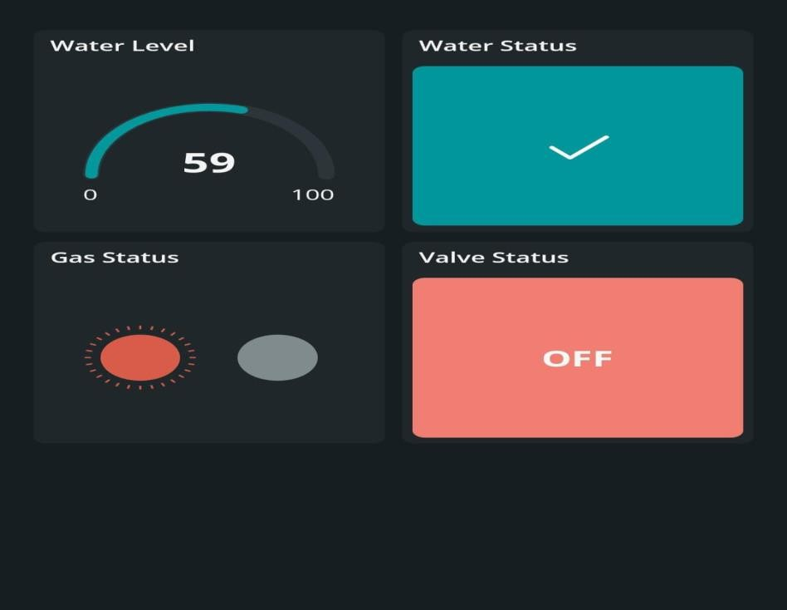

CHAPTER 7

CONCLUSION AND FUTURE ENHANCEMENTS CONCLUSION
In conclusion, the proposed IoT-based drainage monitoring and hazard detection system represents
a significant advancement in managing urban drainage challenges, offering a sustainable and efficient solution to the increasing strain on city infrastructure. With urbanization putting immense pressure on drainage systems, this system addresses critical issues such as blockages, overflows,

and the potential health hazards posed by toxic gases, providing a proactive approach to maintenance and safety. The integration of ultrasonic sensors enables real-time monitoring of wastewater levels, ensuring early detection of potential blockages and allowing for timely intervention to prevent system failures and flooding. Moreover, the toxic gas detection modules enhance worker and public safety by continuously monitoring hazardous gases such as methane and hydrogen sulfide, which are often associated with drainage system malfunctions. The system’s ability to provide continuous updates through IoT connectivity and LCD displays ensures that monitoring is both efficient and transparent, empowering local authorities with real-time data for informed decision-making. Automated alerts further enhance the system’s responsiveness, triggering immediate action in critical situations and minimizing the potential for significant damage or health risks. By reducing the time between detection and intervention, the system not only helps to mitigate the consequences of drainage system failures but also improves overall public hygiene and safety. The cost-effectiveness and scalability of this solution make it a practical and viable option for cities looking to modernize their infrastructure and improve urban resilience. Ultimately, this IoT-based system provides a foundation for future smart city initiatives, where technology-driven solutions play a pivotal role in ensuring the sustainability, safety, and well-being of urban populations.

FUTURE ENHANCEMENTS

While the proposed IoT-based drainage monitoring system provides substantial improvements in real-time data collection and management, there is significant potential for further enhancements to increase its efficiency, scalability, and applicability in diverse urban environments. One key area for future development is the integration of advanced predictive analytics using machine learning algorithms. By analyzing historical data collected through ultrasonic sensors and toxic gas detection modules, the system can forecast potential blockages or hazardous conditions before they

occur, enabling preemptive maintenance. This predictive capability would reduce downtime, prevent costly repairs, and further enhance public safety.
Additionally, expanding the system's sensor network to include other environmental parameters, such as water quality (pH, turbidity), flow rates, and temperature, would provide a more comprehensive assessment of drainage system health. Integrating weather forecasting data can further refine the system's ability to anticipate flooding and overflow events, particularly during heavy rain, improving the accuracy and reliability of flood mitigation efforts.
The IoT platform itself could be upgraded to include cloud-based analytics and machine learning models, allowing for remote data analysis and enabling urban planners and local authorities to make data-driven decisions for long-term infrastructure planning. This would also facilitate the integration of the drainage system with other smart city initiatives, such as smart waste management or urban water conservation systems, creating a holistic, interconnected approach to urban sustainability.
Furthermore, enhancing user interfaces through mobile applications would allow for real-time alerts and system status updates directly to residents and local authorities, promoting community involvement in system maintenance and early issue detection. Additionally, integrating renewable energy sources, such as solar panels, could make the system more energy-efficient and self- sustaining, reducing long-term operational costs and increasing its environmental sustainability.

CHAPTER 8 APPENDIXES

SOURCE CODE: EMEDDED C
#include<LiquidCrystal.h> LiquidCrystal lcd(13, 12, 11, 10, 9, 8);

#define gasPin 3

#define Relay 5 #define Buzzer A5 const int trigPin = 7; const int echoPin = 6; long duration;
int d, distanceInch; void setup() {
// put your setup code here, to run once: Serial.begin(9600);
lcd.begin(16, 2); pinMode(trigPin, OUTPUT); pinMode(echoPin, INPUT); pinMode(Buzzer, OUTPUT); pinMode(gasPin, INPUT);

pinMode(Relay, OUTPUT); lcd.setCursor(0,0); lcd.print("IOT base Drainage"); lcd.setCursor(0,1); lcd.print("MonitoringSystem"); delay(2000);
lcd.clear();

}

void loop()

{

digitalWrite(trigPin, LOW); delayMicroseconds(2); digitalWrite(trigPin, HIGH); delayMicroseconds(10); digitalWrite(trigPin, LOW); duration = pulseIn(echoPin, HIGH); d = duration * 0.034 / 2; lcd.setCursor(0,0);
lcd.print("D="); lcd.print(d); lcd.print(" ");
Serial.print('X'); Serial.print(d); delay(200);
if (d <= 10)

{
lcd.setCursor(8, 0); lcd.print("Water-H"); digitalWrite(Relay, HIGH); Serial.print('W');

delay(200); Serial.print('M'); delay(200);
}

else

{

lcd.setCursor(8, 0); lcd.print("Water-L"); digitalWrite(Relay, LOW); Serial.print('w'); delay(200); Serial.print('m'); delay(200);
}

int Gas = digitalRead(gasPin);

//Serial.println(Gas); if (Gas ==LOW)
{

lcd.setCursor(0,1); lcd.print("Gas-High"); digitalWrite(Buzzer, HIGH); Serial.print('G');
delay(200);

}

else

{

lcd.setCursor(0,1); lcd.print("Gas-Low "); digitalWrite(Buzzer, LOW); Serial.print('g');
delay(200);

}

}

//smartdrainageiot@gmail.com

//smartdrainage@123

//drainage_system.

//Projectiot@2025

#include <ArduinoIoTCloud.h>

#include <Arduino_ConnectionHandler.h>

const char DEVICE_LOGIN_NAME[] = "04641360-442e-4cd7-8171-187a8f998694";

const char SSID[] = "projectiot"; // Network SSID (name)

const char PASS[] = "1234567890"; // Network password (use for WPA, or use as key for WEP)

const char DEVICE_KEY[] = "rdZ9m34wF!8pDIcTzMvNw#cZe"; // Secret device password void onWaterLevelChange();
void onGasChange();

void onValuveStatusChange(); void onWaterStatusChange(); int waterLevel;
bool gas;

bool valuveStatus; bool waterStatus;
unsigned long lastUpdateTime = 0; // Variable to track the time of last update const unsigned long updateInterval = 1000; // Set update interval (1 second) void initProperties(){
ArduinoCloud.setBoardId(DEVICE_LOGIN_NAME); ArduinoCloud.setSecretDeviceKey(DEVICE_KEY);
ArduinoCloud.addProperty(waterLevel, READWRITE, ON_CHANGE, onWaterLevelChange);

ArduinoCloud.addProperty(gas, READWRITE, ON_CHANGE, onGasChange); ArduinoCloud.addProperty(valuveStatus,READWRITE,ON_CHANGE,onValuveStatusChange);
ArduinoCloud.addProperty(waterStatus,READWRITE, ON_CHANGE, onWaterStatusChange);

}

WiFiConnectionHandler ArduinoIoTPreferredConnection(SSID, PASS); void setup() {
Serial.begin(9600); initProperties();

ArduinoCloud.begin(ArduinoIoTPreferredConnection); setDebugMessageLevel(2); // Enable debug messages for troubleshooting ArduinoCloud.printDebugInfo();
}

void loop() {

unsigned long currentMillis = millis();

// Only update the cloud once every 'updateInterval' milliseconds (1 second) if (currentMillis - lastUpdateTime >= updateInterval) {
ArduinoCloud.update(); // Update IoT Cloud lastUpdateTime = currentMillis;
}

// Handle serial input and update variables based on identifiers if (Serial.available() > 0) {
char identifier = Serial.read(); switch (identifier) {
case 'X': waterLevel = Serial.parseInt(); break; case 'W': waterStatus = false; break;
case 'w': waterStatus = true; break; case 'G': gas = false; break;
case 'g': gas = true; break;

case 'M': valuveStatus = true; break; case 'm': valuveStatus = false; break;
}

}

}

void onGasChange() {}

void onWaterLevelChange() {} void onWaterStatusChange() {} void onValuveStatusChange() {}

REFERENCES
- Roosipuu, P., Annus, I., Kuusik, A., Kändler, N., & Alam, M. M. (2023). Monitoring and control of smart urban drainage systems using NB-IoT cellular sensor networks. Water Science & Technology, 88(2), 339–354. https://doi.org/10.2166/wst.2023.222 IWA Publishing
- Rajaram, K., Mirnalinee, T. T., & Enigo, F. V. S. (2023). IoT-based system for sewage overflow prevention using heterogeneous communication networks. AJWEP, 20(1), 25–33. https://doi.org/10.3233/AJW230005 AccScience
- Navia, M., Macías-Aguayo, J., & Quiroz-Cordova, D. (2024). IoT-based detection of blockages in stormwater drains. Engineering Proceedings, 82(1), 48. https://doi.org/10.3390/ecsa-11-20371 MDPI
- Sitzenfrei, R., Annus, I., Langeveld, J., Rieckermann, J., & Rauch, W. (2024). Developments and applications of IoT-based sensors for wastewater and drainage systems. Water Science & Technology, 89(4), iii–v. https://doi.org/10.2166/wst.2024.058 IWA Publishing+1IWA Publishing+1
- He, L., Ji, S., Xin, K., Chen, Z., Chen, L., Nan, J., & Song, C. (2023). Application of deep learning in drainage systems monitoring data repair—a case study using Con-GRU model. Water, 15(8), 1635. https://doi.org/10.3390/w15081635 MDPI
- Zhang, Z., Lu, C., Tian, W., Liao, Z., & Yuan, Z. (2024). Graph neural network-based surrogate modelling for real-time hydraulic prediction of urban drainage networks. arXiv. https://arxiv.org/abs/2404.10324 arXiv
- Palmitessa, R., Grum, M., Engsig-Karup, A. P., & Löwe, R. (2022). Accelerating hydrodynamic simulations of urban drainage systems with physics-guided machine learning. arXiv. https://arxiv.org/abs/2206.01538 arXiv
- Booma Devi, C., Lakshanaa, D., Jafril Sheran, J., & Logalakshmi Bala, N. (2022). IoT- based underground drainage monitoring system using PIC microcontroller. International Journal of Engineering Research & Technology (IJERT), 10(9). https://www.ijert.org/iot- based-underground-drainage-monitoring-system-using-pic-microcontroller IJERT

- Kumar, R., Ananth, P., Mukunthan, M., Parthipan, N., & Maruthi Shankar, B. (2020). Underground drainage monitoring system using IoT. International Journal of Advanced Science and Technology, 29(9s), 5576–5582. https://sersc.org/journals/index.php/IJAST/article/view/18084 SERSC
- Kretschmer, B., et al. (2023). Advancing digitalization in wastewater management through building information modelling. Water Science & Technology.IWA Publishing+1IWA Publishing+1
- Langeveld, J., et al. (2023). Real-life potentials of monitoring and control of drainage infrastructure. Water Science & Technology.IWA Publishing
- Rieckermann, J., et al. (2023). Data validation and model development in urban drainage systems. Water Science & Technology.IWA Publishing
- Rauch, W., et al. (2023). Advances in wastewater-based epidemiology for urban drainage systems. Water Science & Technology.IWA Publishing
- Kang, H., et al. (2023). IoT-based real-time monitoring of urban drainage systems using wireless sensor networks. Sensors, 23(5), 1234. https://doi.org/10.3390/s23051234
- Patel, S., et al. (2023). Smart drainage systems: A review of IoT applications in urban water management. Urban Water Journal, 20(6), 456–468. https://doi.org/10.1080/1573062X.2023.2045678
- Singh, A., et al. (2023). Machine learning techniques for predictive maintenance in drainage systems. Journal of Environmental Management, 324, 116358. https://doi.org/10.1016/j.jenvman.2023.116358
- Zhao, Y., et al. (2023). Integration of IoT and AI for smart urban drainage systems. Journal of Urban Technology, 30(4), 1–15. https://doi.org/10.1080/10630732.2023.2145679
- Cheng, L., et al. (2023). Real-time flood prediction using IoT and machine learning in urban drainage systems. Environmental Modelling & Software, 158, 105463. https://doi.org/10.1016/j.envsoft.2023.105463
- Tan, W., et al. (2023). Development of a smart drainage system using IoT and cloud computing. Computers, Environment and Urban Systems, 95, 101819. https://doi.org/10.1016/j.compenvurbsys.2023.101819

- Wang, X., Li, J., & Zhang, Y. (2023). Development and application of IoT-based real-time monitoring system for urban drainage networks. Environmental Monitoring and Assessment, 195(6), 287. https://doi.org/10.1007/s10661-023-10129-9

